Ephemeral stream contributions to United States drainage networks

Craig B Brinkerhoff1,✉, Colin J Gleason1, Mathew J Kotchen2, Doug Kysar3, and Peter A Raymond2

1 Department of Civil & Environmental Engineering, University of Massachusetts; Amherst, MA  
2 School of the Environment, Yale University; New Haven, CT  
3 Yale Law School, Yale University, New Haven; CT

✉ Correspondence: [Craig B Brinkerhoff <[cbrinkerhoff@umass.edu](mailto:cbrinkerhoff@umass.edu)>](mailto:cbrinkerhoff@umass.edu)

## One-Sentence Summary

Ephemeral streams contribute a significant portion of freshwater to drainage networks and directly implicate United States water quality.

## Abstract

Ephemeral streams flow only in direct response to precipitation and are ubiquitous features of the landscape. A large-scale understanding of their influence on hydrology is underdeveloped and therefore little is known about how ephemeral streams influence downstream water chemistry, creating potential issues for water quality policy (*1*). Here, we model ephemeral stream contributions to the entire contiguous U.S. network of 20,708,899 rivers, lakes, reservoirs, canals, and ditches, finding that they contribute on average 53% of the discharge exported from drainage networks, despite only flowing on average 34 $±$ 13 days a year. The ephemeral contribution is facilitated by small headwater streams, where on average 90% of headwater export is ephemeral. The ephemeral terrestrial-aquatic connection is therefore a substantial pathway through which pollution may enter the downstream perennial drainage network and degrade water quality.

## Main Text

Streams transport nutrients, sediments, pollutants, and other solutes from the land surface to rivers, lakes, reservoirs, and the oceans (*2*–*5*), influencing all downstream water quality (*6*–*8*). The most upland streams (e.g. headwaters) are often ‘ephemeral’ streams, which flow only in direct response to precipitation and are disconnected from groundwater year-round, unlike like larger downstream rivers. Non-perennial streams (which include ephemeral and intermittently dry rivers) account for over half of the global river network (*9*). While much recent work has developed classification models to identify non-perennial streams (*9*–*13*), nearly no work focused specifically on ephemeral streams (*13*) and all work stopped short of assessing the hydrological contributions of non-perennial streams to the overall drainage network at broad spatial scales. While it is regionally established that headwater streams contribute meaningfully to downstream water quantity and quality (*14*, *15*), we presently have no explicit assessment of ephemeral contributions to global-scale hydrology, nor their potential water quality ramifications.

This gap in knowledge is distinctly important in the United states, where ephemeral streams were recently removed from Clean Water Act (CWA) jurisdiction (along with ‘disconnected wetlands’) (*1*). The operational definition of WOTUS is a contentious topic in the United States and has received considerable attention from environmental groups, farm lobbying groups, and politicians since the CWA was enacted in 1972 (*6*, *16*).

In this context, here we use a simple geomorphic model to identify ephemeral streams by comparing long-term water table depths with streamline presence in 20,708,899 discrete streams, rivers, lakes, reservoirs, canals, and ditches across the contiguous United States (CONUS) (*17*). We then use published groundwater, discharge, runoff, precipitation, and network routing models (*18*–*22*) to quantify the fraction of each river’s mean annual discharge that was contributed by upstream ephemeral streams. We also quantify how frequently ephemeral streams flow (*17*). We define and discuss the metrics that make up our assessment (equations S1-S3), validate individual model components (Figs. S1-S5), and test parameter sensitivity when necessary (Figs. S6-S9) (*17*). Our model is a conservative scenario for CONUS stream ephemerality (Text S1) and thus represents a lower bound estimate for the ephemeral influence on United States drainage network hydrology.

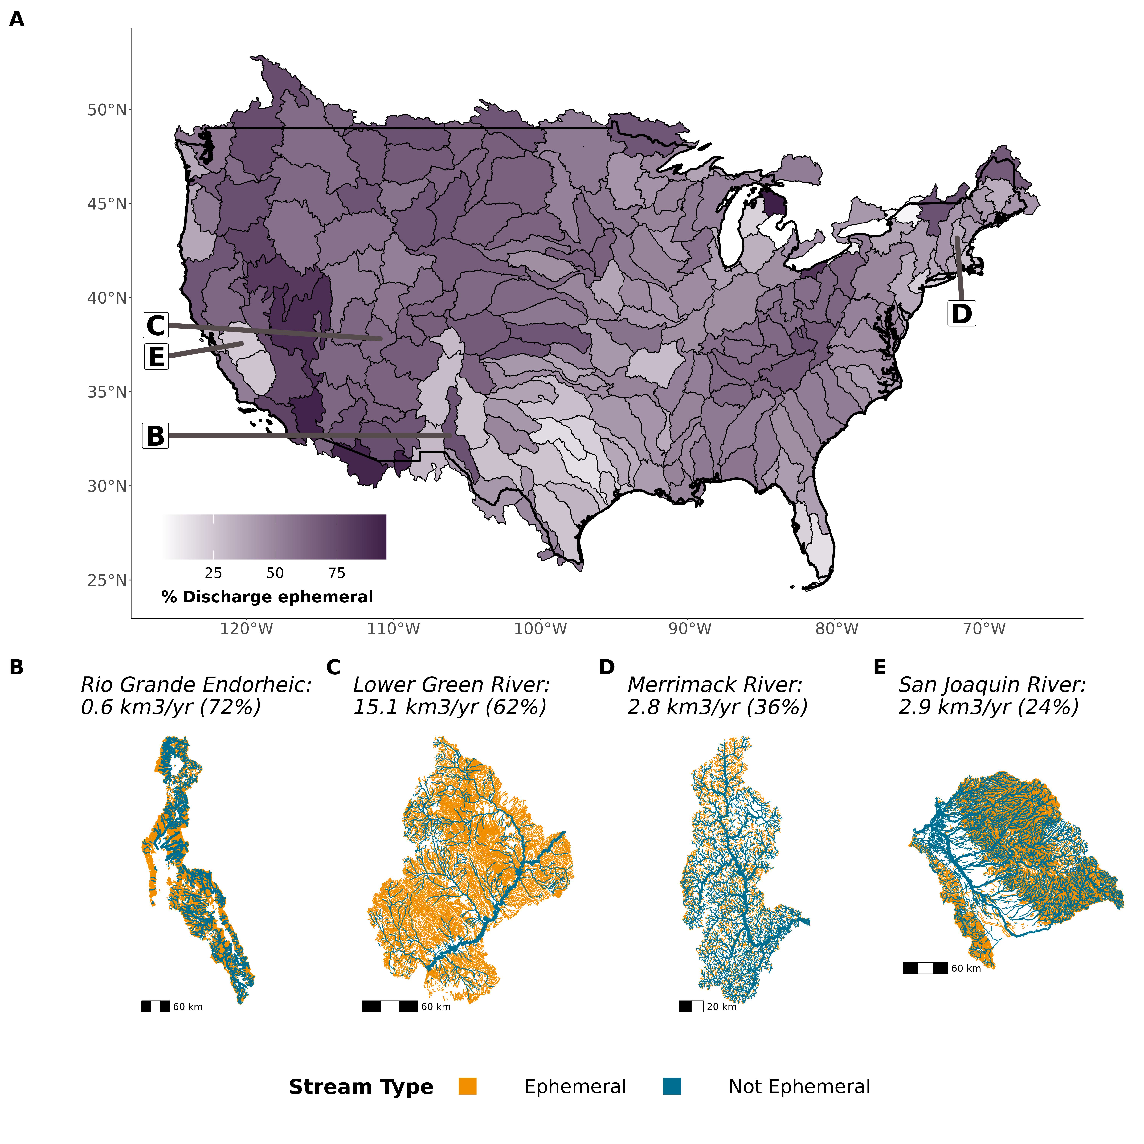

Fig. 1: Ephemeral fraction of discharge exported from drainage networks. (A) Contiguous United States map of the fraction of discharge that is ephemerally-sourced (equation S1). (B-E) Drainage network maps and ephemeral export fractions for four representative basins: (B) endorheic desert basin, (C) semi-arid western basin, (D) temperate, forested basin, and (E) a heavily engineered valley basin. Reach size corresponds to logarithmic bins of streamflow and is relative to map scale. Other basins are mapped in Fig. S10.

On average, 53% of annual drainage network export (water volume) is contributed by upstream ephemeral channels. This varies significantly across basins (from 4% to 95%), with regional hotspots where ephemeral streams most dominate the landscape: the deserts of the American southwest and the endorheic Great Basin (Fig. 1a). However, ephemeral contributions to discharge are consistently high across across CONUS: 60% of networks export water that is at least 50% ephemeral. Even the largest rivers in the United States export large volumes of ephemeral water: the Mississippi River export is 50% ephemeral and the Colombia export is 68% ephemeral. Given that discharge generally accumulates in drainage networks, Fig. 1a is theoretically anticipated by upstream ephemeral network extent (Fig. S1c, Text S1). We also express ephemeral contributions has a function of drainage area (Fig. S11, equation S2), where on average 61% of a basin’s upstream drainage area is ephemeral.

Ephemeral stream hydrography, largely governed by groundwater fluxes and watershed geomorphology, is a result of both topography and climate (*23*, *24*). In the East, ephemeral streams are most numerous in upland settings: the northern Merrimack river basin (Fig. 1d) drains the White Mountains, where steep channels sit just above the water table and only run in response to rain and snow events. In much of the West, where the water table is kilometers below the surface, ephemeral streams can dominate the landscape (Figs 1b, 1c, S10). In hybrid basins, sharp mountain/valley contrasts exist: California’s San Joaquin basin (Fig 1e) has significant ephemeral presence in its high mountain headwaters, but nearly no ephemeral contribution from the Central Valley where there is persistent surface groundwater. Our model does not account for anthropogenic groundwater pumping (*17*) and is likely under-estimating ephemeral streams where pumping is significant. Ephemeral streams will only become more frequent as groundwater pumping intensifies and water tables lower further (*25*, *26*).

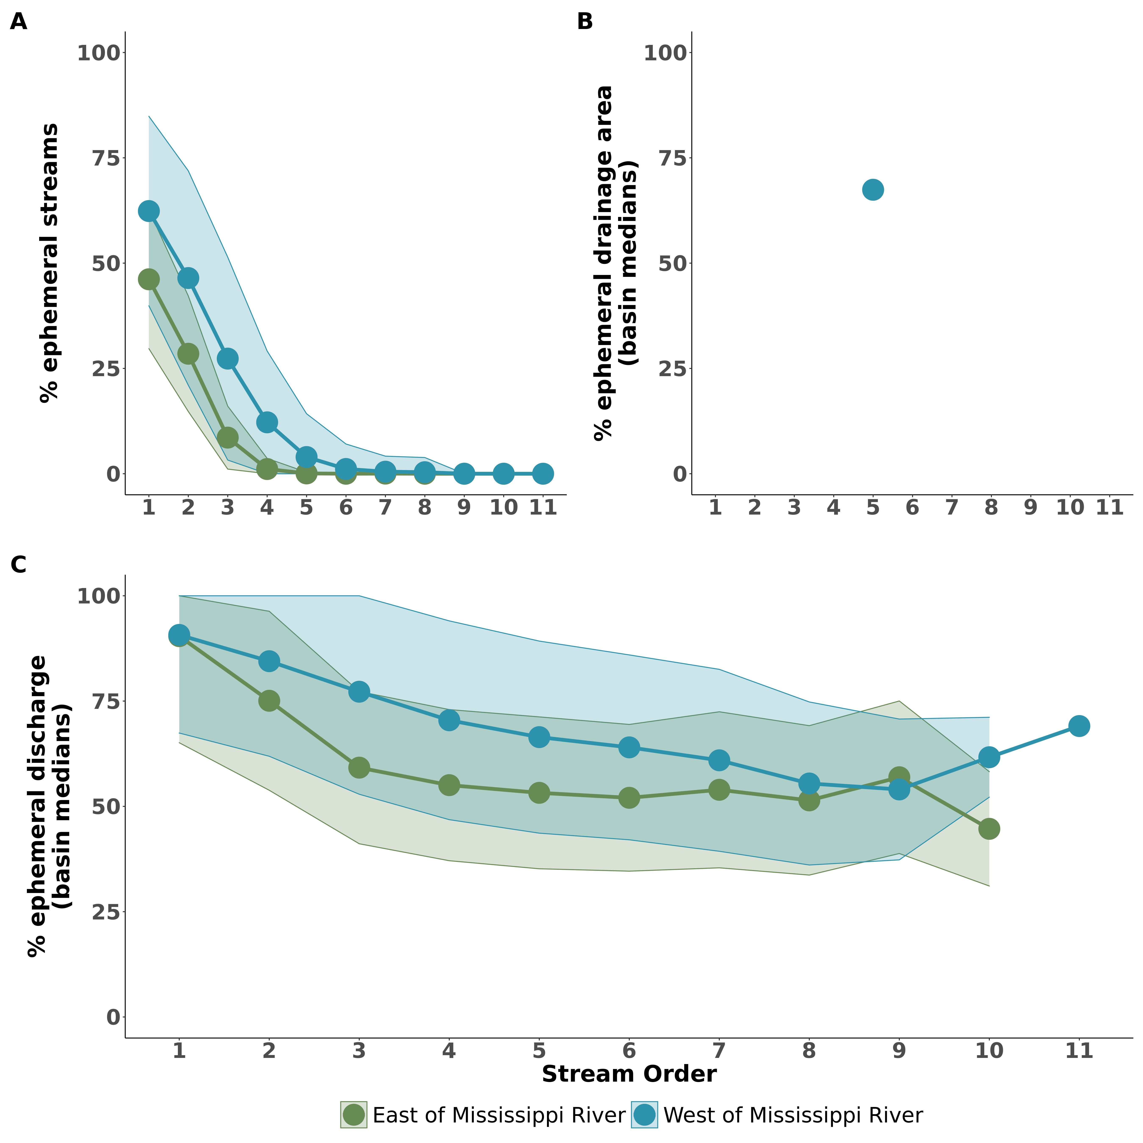

Fig. 2: Ephemeral fraction of discharge internal to drainage networks. (A) Distributions of the median ephemeral discharge fraction per stream order, where points and riboons are the means and standard deviations across CONUS basins (respectively). (B) Same for the median ephemeral drainage area fraction. The ribbons are not present in the 11th order, where only a single basin has an ephemeral stream.

Internal to drainage networks, stream size exerts a critical control on ephemeral contributions (Fig. 2). On average, median first-order discharge is 90% ephemeral across all CONUS basins and nearly equivalent east and west of the Mississippi River (90% versus 91%, respectively). Hereafter, we refer to these regions as ‘east’ and ‘west’. The ephemeral fraction decreases more rapidly with stream size in eastern basins to approximately 50% by the 4th order, while it decreases linearly in western basins (Fig. 2c). The ephemeral drainage area fraction tracks similarly (Fig 2b). Overall, these results are driven by the sheer number of ephemeral steams in orders 1-3 in the east and 1-5 in the west (Fig 2a).

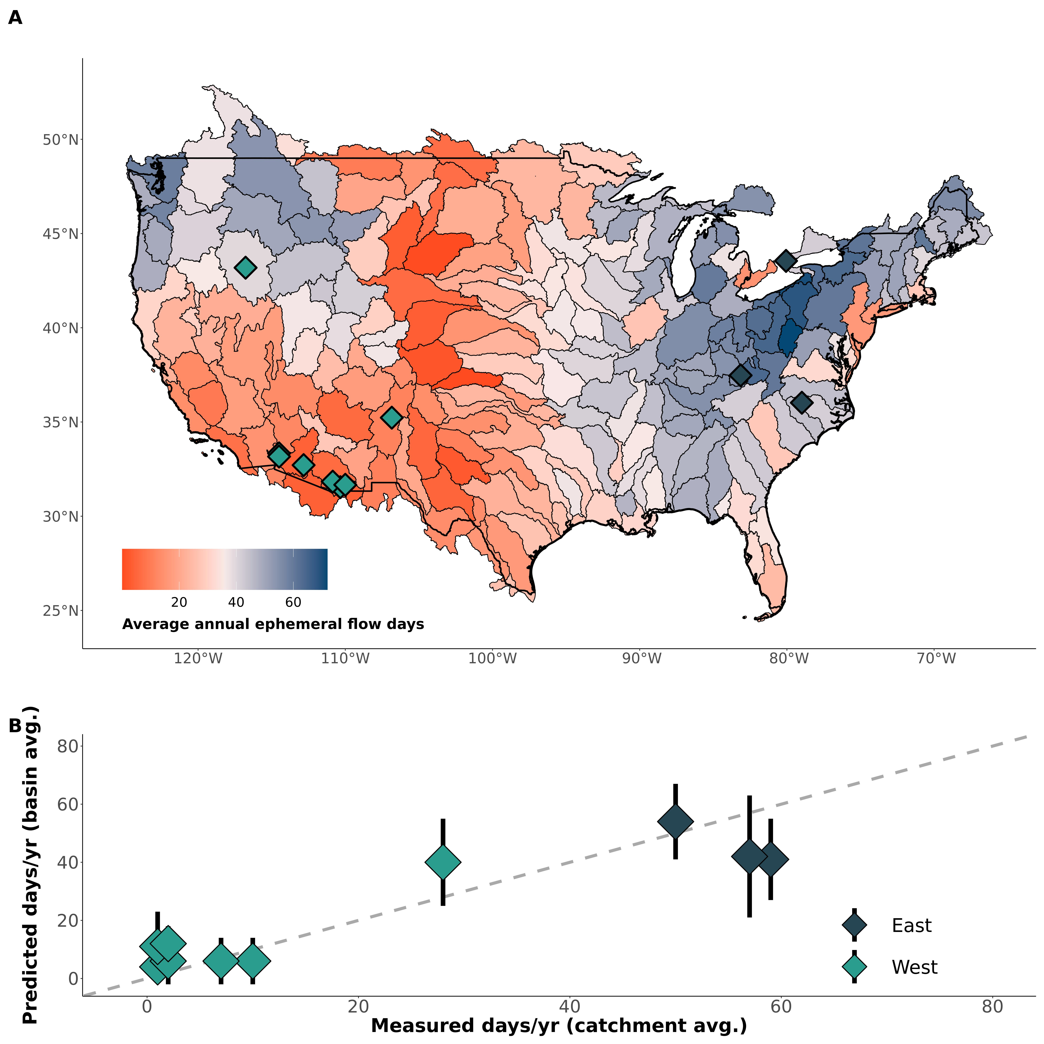

Fig. 3: (A) Contiguous United States map of the average number of days that ephemeral streams flow per year, with points indicating approximate locations of field verification data. (B) Verification of model results with field data. Black bars represent 1 $σ$ uncertainty (*17*). Ephemeral flow frequency manifests as a delicate balance between hydro-climatology controlling the size and occurrence of runoff events and geomorphology controlling the amount of accumulated runoff needed to produce streamflow.

The significance of the ephemeral fraction of discharge (Figs. 1-2) is underpinned by how infrequently they flow (Fig. 3a). Ephemeral streams flow no more than 72 $±$ 21 days in an average year, with a mean of 34 $±$ 13 days. Ephemeral flow frequency largely follows topographic and climatic patterns: in western basins they only flow 18 days a year on average, while they flow NaN days on average in eastern Basins. In the southwest deserts, this drops to an average of 18 days a year. Our simple, completely uncalibrated model uses only a precipitation model, runoff data, and geomorphic scaling theory, yet it reasonably matches independent in situ measurements of catchment-averaged, ephemeral flow frequency (Fig. 2b) (*17*). With such infrequent flow, our results (Fig. 3) suggest that runoff for specific flow events is much greater than mean annual runoff. When ephemeral streams actually flow, they likely dominate the downstream network’s response and shunt pollutants and other solutes downstream at even great rates (*2*).

**Paragraph about implications for water chemistry from Pete.**

**Room here for a final paragraph on implications, regulations, policy, etc. from Doug and Matt.**

## References

references bust be moved here manually for Science submission

## Acknowledgements

We thank Dr. Ying Fan Reinfelder, the USGS, and the EPA for making their data and/or models freely available. We also thank Brian Saccardi for helping manually verify portions of the basin routing scheme. All modeling was performed on the Unity cluster at the Massachusetts Green High Performance Computing Center (MGHPCC).

## Funding

Am I missing anything? Craig Brinkerhoff, Peter Raymond, and Colin Gleason were supported by *WROL*. Craig Brinkerhoff was also supported by *FINESST*.

## Author Contributions

* Conceptualization: PAR, CBB, MJK, DK
* Methodology: CBB, PAR, CJG
* Investigation: CBB, PAR, CJG, MJK, DK
* Visualization: CBB
* Supervision: PAR
* Writing- original draft: CBB
* Writing- review & editing: CBB, CJG, PAR, MJK, DK

## Competing interests

Authors declare that they have no competing interests.

## Data and materials availability

**blah blah blah**.

## Supplementary Materials

* Materials and Methods
* Figs. S1 to S11
* Tables S1 to S5
* References 26-54



# Supplementary Materials for

Ephemeral stream contributions to United States drainage networks

C.B. Brinkerhoff, C.J. Gleason, M.J. Kotchen, D. Kysar, P.A. Raymond

Correspondence to [cbrinkerhoff@umass.edu](mailto:cbrinkerhoff@umass.edu)

## This PDF file includes:

* Materials and Methods
* Text S1
* Figs. S1 to S11
* Tables S1 to S5

## Materials and Methods

To perform a first continental-scale assessment of ephemeral stream contributions to CONUS drainage networks, we use 3 properties to frame our exploration: ephemeral flow volume, ephemeral drainage area contributions, and ephemeral flow frequency (Section 2). All modeling and analysis was performed on the Unity Cluster at the Massachusetts Green High Performance Computing Center (MGHPCC) using publicly available datasets, models, and entirely free and open-source geoprocessing tools in the R programming language. All data and models used in this analysis are described in Table S1.

### 1 Drainage network framework

#### 1.1 Overview

CONUS drainage network hydrography is defined by the United States Geological Survey (USGS) National Hydrography Dataset High-Resolution (NHD-HR) built at 1:24,000 map scale (*19*). This is the updated and higher-resolution version of the commonly used National Hydrography Dataset and is still in development by the USGS. We use the data publicly available as of Spring 2022. This is the highest resolution hydrography data available and is often treated as a gold-standard to benchmark hydrography models against. Compared against digital elevation model (DEM)-based hydrography, there is no necessary assumption of a uniform drainage area threshold. Rather, streams and rivers are geo-tagged in the model using a variety of methods from DEMs, map digitzation, and field visits. The NHD-HR is discretized into ‘reaches’, which correspond to mass-conserved segments of rivers, streams, ditches, canals, lakes, and reservoirs. The NHD-HR uses artificial flowpaths to maintain network topology through lakes and reservoirs, and here we use a previous framework to incorporate discretized lake/reservoir bathymetry into our model that accounts for complex lake/reservoirs with multiple river inputs (*22*). The NHD-HR also uses nested drainage basins across 12 scales. We run our model at the 4th level and our mapping validation at the 2nd level. This was done based on data resolution, data availability across the United States, and ease of interpretation.

As will all human-built products, NHD-HR data quality varies across CONUS. We identified significantly higher drainage densities in the NHD-HR for the state of Indiana (often 1-2x the stream orders as other portions of a given basin in adjacent U.S. states). For these basins, we manually removed the lowest 1 or two stream orders within the Indiana portions of these basins, until the whole-basin drainage density was visually consistent. We also removed all divergent reaches, i.e. minor flowpaths that diverge from the main downstream path of flow. We did not remove the rest of the flowpath downstream of a divergent reach if there was another, non-divergent source that joined and made the path no longer divergent. Divergent channels are generally alternative flowpaths for the same rivers, and so we remove them to avoid double-counting reaches in the same, multi-channel river.

#### 1.2 Discharge model

Each reach is associated with a mean annual discharge $\overset{‾}{Q}$ as modeled by the USGS (*19*). These are obtained through a runoff routing scheme that additionally accounts for evapotranspirative losses (i.e. losing streams). The USGS validated this model using mean annual streamflow for 1970-2000. To confirm model performance for more recent years, we extend the validation to 1970-2018 using all USGS streamguages with sufficient data (Fig. S4- 4,044 gauges). The discharge model is validated in Fig. S4, where the model robustly captures mean annual discharges for 1970-2018 and performs comparably to a similar discharge model used to map global river intermittency (*9*).

#### 1.3 Hydraulic Geometry

We use hydraulic geometry scaling to obtain broad estimates of mean annual river, and lake/reservoir depth that are needed to assess ephemerality (Section 3). For rivers, canals, and ditches we used the relation from (*27*), who fit an equation of the form $H=c{\overset{‾}{Q}}^{f}$ on over 500,000 USGS in situ measurements of river channel depth *H* and discharge *Q*. For lakes and reservoirs, we mass-conservation to obtain average depths from lake/reservoir volume (*Vol*) and surface area *SA*. *Vol* was scaled using an existing equation of the form $Vol=a{\left(SA\right)}^{1.2}$ (*28*), developed using the Hurst coefficient for self-affine surfaces and existing datasets.

#### 1.4 Field data on stream ephemerality

We use a dataset of field assessments of ‘stream ephemerality’ to validate our stream classification model. This dataset comes from three sources: a) EPA WOTUS jurisdictional determinations, b) USGS streamgauges, and c) field assessments of New England streams. These are described next.

The EPA Jurisdictional Determinations dataset (*29*) consists of site assessments (as of 06/20/2022 when downloaded) for WOTUS status made at the landowners request, where status was determined under the at-the-time definition for WOTUS extent. We filter this dataset to include only determinations made under the NWPR after it was enacted in 2020, which includes an explicit category for ephemeral streams. This amounts to over 60,000 distinct jurisdictional determinations (including multiple determinations in the same reach, over space and time) and forms the bulk of our dataset. To make the dataset copacetic with our model, we remove data not associated with surface water features directly connected to the drainage network: adjacent/riparian wetlands, drylands, upland terrestrial sites, upland or non-adjacent wetlands/ponds/depressions, croplands, wastewater plants, and groundwater. We retained all other determinations that are directly connected to the drainage network (rivers, lakes, reservoirs, canals, ditches, stormwater control features, and artificial surface water features) and recast all determinations as ephemeral or non-ephemeral.

We supplement the Jurisdictional Determinations dataset with the USGS streamgauge network. Because the EPA Jurisdictional Determinations are done on a voluntary basis at the landowner’s request, it is biased towards those surface waters whose WOTUS status is questionable and requires a proper field assessment to elucidate. Thus, the EPA Jurisdictional Determinations rarely include larger (generally perennial) rivers. To make sure we are also correctly classifying these rivers, we use gauged rivers (section 1.2). All gauged rivers that, on average, are flowing 95% of the year (for 1970-2018) are assumed to be non-ephemeral, and are added to the dataset as such.

Finally, we manually assess stream ephemerality in the northeastern U.S. as our filtered and cleaned dataset includes no ephemeral reaches in this region. We follow the ‘expert protocol’ used by North Carolina’s department of Water Quality for assessing stream ephemerality (*30*). This protocol uses geomorphic, hydrological, and biotic indicators of seasonally and/or permanently high water tables to assess stream permanence. We use our local knowledge to identify streams we thought are likely to be ephemeral, verify they are present in the hydrography (but do not look at the model result a priori to avoid biasing our assessments) and assess the channels following the protocol. Classification results are in Table S2 for the five sites. All streams are assessed over 48 hours from the most recent rain event to avoid the influence of delayed runoff in the channel that might be mistaken for baseflow. Note that we do not perform full soil assessments nor species counts as the protocol technically specifies, but instead perform rapid visual assessments that favor speed of classification over thoroughness. Per the protocol, none of these channels are close enough to being classified as intermittent (Table S2) that we feel confident our rapid assessments are sufficient. While we only assessed five ephemeral rivers, they provide at least some validation data in the northeastern U.S.

We join the three datasets to the hydrographic framework by snapping each field assessment to the nearest reach. Despite it’s high resolution, the NHD-HR does not contain every stream in the U.S. and many of the field sites are not expected to be associated with a reach. In general, classification performance should decrease as the snapping threshold increases due to a misassignment of field data to the wrong rivers, though we want to test how sensitive it actually is. First, we re-project all data using the Universal Transverse Mercator (UTM) projection system to ensure snapping distances are regionally accurate. Then, we test a range of snapping thresholds from 7.5m to 60m as a sensitivity test. Additional discussion on this sensitivity test is explained in Section 3.3. Ultimately, we settle on a threshold of 7.5m. After snapping, we assign the most frequently occurring field assessment along the reach as its ‘true assessment of ephemerality’. If there is a tie between frequency of occurence (meaning there is no consensus on whetehr the reach is ephemeral or non-ephemeral), we remove those points from the data dataset. Ultimately, we have 6,761 field assessments of reach ephemerality to validate our model. Figure S1b maps the regional number of these data for all of CONUS.

### 2 Calculations

We calculate a suite of metrics by routing through the drainage network, from most upstream to downstream reach, and calculating equations S1 and S2. When a basin discharges into a downstream drainage network, we pass the appropriate reach values to the next downstream basin. Below are the metrics that we calculate for all 20708899 reaches in the CONUS drainage network. To calculate the relative ephemeral flow volumes (and drainage areas) being exported from each basin (Fig. 1a and S11), we sum up the ephemeral flow volumes and contributing areas for all terminal reaches in the basin and then re-calculate equations S1 and S2.

The relative ephemeral flow volume $E_{Q}$ is the average fraction of a reach’s discharge that was ‘ephemerally-sourced’, or entered the drainage network in an upstream ephemeral channel (equation S1). $Q_{L}$ is the lateral runoff contribution for the current reach, *Q* is accumulated discharge, *F* is an ephemeral flag, and *i* indexes the reaches immediately upstream. *F* is a binary flag that ‘turns on’ lateral runoff when the stream is ephemeral. Losing streams (when discharge decreases downstream due to evapotranspirative losses or groundwater seepage) can make equation S1 go below 0% or above 100%. We bound the results at 0-100% because, relative to the river channel, these values are equivalent to 0% or 100%, respectively.

$$E_{Q}=\frac{Q_{L}F+\sum_{i=1}^{I}{Q_{i}E_{Q_{i}}}}{Q}\left(S1\right)$$

The relative ephemeral area contribution $E_{p_{A}}$ is the average fraction of a reach’s upstream drainage area that is ephemeral (equation S2). $A_{L}$ is the lateral catchment area for the current reach and *A* is upstream drainage area.

$$E_{A}=\frac{A_{L}F+\sum_{i=1}^{I}{A_{i}E_{A_{i}}}}{A}\left(S2\right)$$

At the basin scale, we calculate ephemeral flow frequency $E_{f}$ as the fraction of an average year (in days) that ephemeral streams are flowing. We calculate this using equation S3, where *i* is mean daily runoff depth, $i_{min}$ is a minimum runoff depth threshold, and day *d* in the multi-year record *D*. This calculation is elaborated on in section 5. Equation S3 is mapped in Fig. 3a.

$$E_{f}=\frac{\sum_{d=1}^{D}{\left(i≥i_{min}\right)}}{D}*365\left(S3\right)$$

### 3 Identifying ephemeral streams

#### 3.1 Model

Our model relies on a geomorphic definition for ephemerality and avoids the potential pitfalls of training/validating a statistical classifier on streamgauges, which are by definition biased towards larger, non-ephemeral streams (*31*, *32*).

We use a ~1km global soil hydrology model for mean monthly estimates of the water table depth (*WTD*)(*18*, *33*). Those authors coupled a vertical soil water balance with an inverse model that solves for groundwater recharge, lateral groundwater discharge, water table depth, and plant root uptake from evapotranspirative demand, inferred from remotely sensed leaf area index (*18*). The model ignores local, perched aquifers and anthropogenic pumping in favor of a broad, long-term average *WTD*, as is common in global-scale groundwater models (*34*, *35*). Ignoring pumping likely leads to an underestimation of ephemeral streams, as the modeled water table is artificially high relative to the observed water table that has been lowered at the hands of pumping. Under this scenario, we misclassify ephemeral streams as perennial and additionally underestimate the ephemeral influence on streamflow and water quality.

We extracted the mean *WTD* along each reach for 0 discrete reaches across CONUS. We perform an initial classification of ephemeral/not ephemeral based solely on water table depth below the drainage feature: if *WTD* is deeper than river depth plus a 1cm buffer, for all twelve months of the year, it is classed as ephemeral. To avoid misclassifying streams with an intermittently high/low water table, this must hold true for all twelve months of the year. We treat all lakes/reservoirs as non-ephemeral because the NWPR definition for ephemeral is limited to streams.

Next, we route through the network from upstream to downstream, cleaning up impossible scenarios and amending our initial classification to a more conservative estimate. Specifically, once a drainage path becomes ‘not ephemeral’, it must stay that way downstream because, over long-term averages, some amount of water is advected from upstream, whether perennially or intermittently. Even if it is a ‘losing stream’ this assumption must be true as the river will export some amount of water, even if very little. Finally, we handle two unique scenarios:

* Following NWPR rules, we only count rivers/streams as ephemeral and recast all ephemeral canals and ditches as non-ephemeral. These features fall under different WOTUS rules and are not the focus of this study.
* While Mexican and Canadian ephemeral streams contribute streamflow to the CONUS drainage network, they are not under U.S. jurisdiction and so are also recast as non-ephemeral.

Routing between basins was facilitated by a custom routine which runs the drainage network routing in parallel across basins at the same ‘processing level’, and then efficiently passes exported parameters of interest to the basin immediately downstream in the next processing level.

#### 3.2 Validation

Ephemeral classification accuracy is assessed using the field assessment dataset (Section 2). We assess performance using regional classification accuracy, sensitivity (the true positive rate), specificity (the true negative rate), and “informedness”, which is also called the true skill statistic (*TSS*) or Youden’s *J* depending on the literature (*36*). See Table S3 for metric definitions. *TSS* is equal to the sensitivity + specificity - 1. It intuitively represents the performance improvement over a random classifier, i.e. a score of zero indicates that the model is equivalent to random guessing. Mathematically, *TSS* equals the distance (in units of sensitivity) between a point on the ROC curve and the random classifier. *TSS* is more robust to class imbalances than simple percent accuracy, and it has been used in the past to assess headwater and ephemeral mapping models (*12*, *13*), so we use it here to compare against existing models. Regional *TSS* is mapped in Fig. S1, regional sensitivity and specificity are mapped in Fig. S2, and boxplots of all regional metrics are Fig. S3. To confirm our results are not dependent on the snapping threshold used, we test the sensitivity of CONUS-wide classification accuracy to the snapping threshold. We find it stable when the threshold is at least 10m (Fig. S6). The choice of this threshold is elaborated on in Section 3.3. The validation results are discussed in Text S1.

#### 3.3 Extending the ephemeral network

As alluded to in Section 1.4, much of our ephemeral field data does not fall on the mapped drainage network and instead are streams too small to be explicitly represented in our hydrography. While this drainage network framework is the highest resolution available, it inevitably has a lower bound on the streams that it includes (particularly with respect to ephemeral channels). To assess the amount of ephemeral streams we are missing, we use Hortonian river network scaling (*37*) to extend the ephemeral stream network to best reproduce the observed distribution of the ephemeral field assessment dataset (section 2). This approach assumes the following:

* All scaled streams are ephemeral.
* Ephemeral streams aggregated from many CONUS drainage networks will fit Hortonian scaling theory. This is valid as Horton ratios are a statistical inevitability of stream ordering and do not represent an inherent geomorphic process (*38*–*40*), but rather arise fromm hydrography resolution and definitions. We use a consistent CONUS-scale product, so this is reasonable.
* The section 2 ephemeral field data is representative of the distribution of ephemeral streams across CONUS. Because this data consists of voluntary field assessments, it is very likely an underestimate of ephemeral stream presence. Actual estimates are likely even greater.

Equation S4 is the Horton law of stream numbers, which is a power-law function relating stream order $SO_{m}$ to the number of streams in the $m^{th}$ order $N_{m}$ (*37*). $R_{B}$ is the Horton ratio and $N_{max}$ is the number of streams in the largest order. $R_{B}$ is solved via least-squares regression. Equation S4 can be re-expressed as equation S5, where *k* is the hypothetical ephemeral stream order(s) not associated with a model reach. Our validation data (section 1.4) provides us with $N_{k}$ (which is, again, likely underestimated), enabling the direct calculation of $SO_{k}$. We tested the sensitivity of this calculation to the snapping threshold used to join the validation data to the hydrography and found that the ephemeral river network most closely matched Hortonian theory with a snapping threshold of 5-15m (Fig. S5-S7). Otherwise, this scaling relationship began to break down.

$$N_{m}=N_{max}*R_{B}^{SO_{max}−SO_{m}}\left(S4\right)$$

$$SO_{k}=\frac{log\left(N_{k}\right)−log\left(N_{max}\right)−SO_{max}log\left(R_{B}\right)}{−log\left(R_{B}\right)}\left(S5\right)$$

Using equation S5, we find that one additional ephemeral stream order should be added to our drainage network to reproduce the field data (Fig. S5). Given the likely significant omission errors in our field ephemerality data, one additional stream order is a lower bound. This conveniently means that we can treat all accumulated flow in first-order stream channels as lateral runoff (i.e. $Q_{L}=Q$ ), however it does assume that all streams upslope of the ‘first-order’ streams in the model are the same classification of ‘ephemeral’ or ‘non-ephemeral’.

### 4 Estimating ephemeral flow frequency

#### 4.1 Data

We estimate the flow frequency of ephemeral streams via the mean annual number of days per year that they flow ($N_{flw}$). We do this using mean annual, weighted-average runoff data for 1970-2021 (*20*), a daily precipitation model for 1980-2010 (*21*), and geomorphic theory. Thus the model is purposefully simple but globally scalable and there is no calibration or use of the field data (Fig. 2b, Table S4).

We use field data only to verify the model’s performance. Note that field $N_{flw}$ data is quite uncommon and measured in very different ways at very different temporal resolutions. To our knowledge, we use all existing field data (*41*–*48*) that provides sufficient information to calculate $N_{flw}$ (Table S4). To get all data in a uniform format, we calculated mean annual $N_{flw}$ at each gauged stream (if applicable), then took the catchment average $N_{flw}$ across the gauged streams (again, if applicable). This averaging was not done in catchments with insufficient data and therefore significant uncertainties exist in many of these estimates that are presently not quantifiable.

Length of the timeseries varies significantly, from approximately 1/3 of a year in Guelph, Ontario to 45 years of sub-daily data in the Walnut Gulch Experimental Watershed in Arizona. Data from (*48*) exist for three sites within a catchment in Guelph, Ontario that do not flow into the United States. However, they are located approximately 15 km from one of our model basins that do flow into the U.S. (Figure 2) and so we use that basin for verification. The Guelph, Ontario data is only for 1/3 of the year (approximately July to October). When necessary, sub-daily timeseries were downscaled to mean daily values. The Duke Forest site in North Carolina includes an intermittent main stem where the flow was recorded, however the rest of the drainage system is ephemeral (*41*). To obtain a mean annual estimate, we assumed the frequency of flow was the same for March to June and that the ephemeral channels do not run in the winter (November to February), i.e. we doubled the $N_{flw}$ measured in their study. Likewise, the Robinson Forest data was only assessed for the latter half of a year, though reports indicate that flow only generally occurs 1-2 times in the remaining months (*49*), so we added that to the calculation.

#### 4.2 Model

Traditionally, streams are viewed as a surifical expression of groundwater (*50*). However, by definition ephemeral streams expand beyond the boundary of the surface extent of baseflow (*51*). Because they ave no baseflow component (which is simultaneously composed of both lateral and accumulated groundwater), ephemeral flow frequency is purely a manifestation of surface runoff generation. This drastically simplifies our modeling needs and allows ephemeral flow frequency to be modeled solely via generation of surface runoff and no baseflow.

In that context we first calculate a mean annual basin runoff ratio $i_{r}$ to convert precipitation *P* to stream runoff *I* and vice versa. The runoff ratio (equation S6) reflects the proportion of rainfall on the basin that winds up as stream runoff, where the implicit losses are via groundwater recharge and evapotranspiration. Using a mean annual $i_{r}$ as we do also implicitly handles snowmelt runoff in winter.

$$i_{r}=\frac{i}{P}\left(S6\right)$$

This runoff ratio and the 30 year daily timeseries of precipitation are used to determine how often runoff is generated in ephemeral streams (equation S3). Daily precipitation depths are converted to daily, basin-averaged stream runoffs using $i_{r}$. Streamflow then occurs when daily runoff exceeds some runoff threshold. We tally all days when flow occurs over the 30 years of precipitation data and calculate a mean annual $N_{flw}$, which is mapped in Fig. 2a. For a handful of basins on the Mexican/Canadian borders, there are no USGS gauges and no runoff data. We use the mean annual runoff values from adjacent basins (the “closest” as assessed visually) and assume it holds constant in these basins.

The runoff threshold in equation S3 ($i_{min}$) is functionally a bias corrector. It can be conveniently scaled as a function of the average ephemeral catchment size: larger ephemeral catchments need less runoff to generate streamflow due to greater flow accumulation. We use equation S7, where $W_{min}$ is a field-verified consistent headwater stream width identified across varied landscapes and climates by (*52*). *a* and *b* are empirical constants for a global $w=aQ^{b}$ scaling relation (*27*) that converts headwater stream width to headwater streamflow. $A_{m}$ is the drainage area for reach *m*.

$$i_{min}=\frac{{\left(W_{min}/a\right)}^{1/b}}{A_{m}}\left(S7\right)$$

We also parameterize watershed ‘memory’ (a bulk parameter representing delayed arrival of bulk surface runoff (representing lumped Dunnian, Hortonian, and/or interflow processes) to the drainage network. The memory parameter keeps streams ‘turned on’ for a number of days following a day identified as flowing. Memory parameter assignment was guided by a recent analysis (*53*), which calculated the streamflow memory of rain events for 671 watersheds in CONUS, including many with groundwater influence. They found a median memory of approximately 4 days. Nearly all of the watersheds with memories longer than 4 days had baseflow signal in their hydrographs, so we took 4 days and reduced it to apply to ephemeral streams, settling on 2 days.

Given the simplicity of our $N_{flw}$ model, we sought to ensure the results are not particularly sensitive to our model and our chosen parameter settings. As a first order comparison, we roughly calibrate a global-scope $i_{min}$ using the available $N_{flw}$ data, acknowledging that it is biased towards southwestern desert ephemeral streams. Nonetheless, it is useful to compare calibrated runoff thresholds against equation S7 as a gut check. We test a range of runoff thresholds, holding all other parameters constant and calculating the mean absolute error in $N_{flw}$. A runoff threshold of 0.25 mm/day (Fig. S8a) yielded the best performance and is in line with the values our theoretical model returns (Fig. S8b), particularly when considering the data bias towards desert catchments where thresholds are likely to be greater than similar, more humid basins.

Secondly, we did a sensitivity test where we re-calculate the $N_{flw}$ across all basins under four runoff scenarios that test the influence of runoff memory and $i_{r}$ on the final results. For this test, we use equation S7 and run the model under the four scenarios detailed in Table S5. At the basin-scale, results change only slightly (Fig. S9), suggesting that runoff memory and efficiency are not the primary drivers of basin-averaged ephemeral flow frequency at such a coarse scale.

#### 4.3 Verification

We verify the model against existing field measurements of ephemeral flow frequency (section 5.1, Fig. 2b). Because of the limited available data on $N_{flw}$, we refer to this as a model verification: all we can do is confirm that the model is reasonably realistic. We leave model refinement and constraining field-measured $N_{flw}$] to future work.

### 5 Uncertainty Analysis

We quantify uncertainty in $N_{flw}$ (Fig. 2a), where parameter uncertainty comes from *a*, *b*, and $W_{min}$ in equation S10 for $N_{flw}$. To estimate, we use a Monte Carlo simulation. We sample 1,000 random parameter sets from the *a*, *b*, and $W_{min}$ distributions described in (*52*) and (*27*). We then push each parameter set through the section 5.2 calculations and extract the standard deviation from the resulting distribution as $δN_{flw}$.

## Text S1: Model performance

Ephemeral mapping performance varies across the United States. Regional average *TSS* is 0.62 (Fig. S2a), average regional accuracy is 86% (Fig. S1a), average regional sensitivity is 72% (Fig. S3a) and average regional specificity was 90% (Fig. S3b). Performance is best in the northeastern U.S. and western U.S. (average *TSS* of 0.76), while performance was worse in the Midwest and Great Plains (average *TSS* of 0.38). Specificity is uniformly strong across CONUS (Fig. S3b) but sensitivity is poor throughout the Great Plains and the western Gulf Coast (Fig. S2a). Overall, we outperform the only existing continental-scale ephemeral stream map (*13*), which reported a CONUS *TSS* of 0.45, sensitivity of 63%, and specificity of 83%.

We also note that our scaling analysis (section 3.3, Fig. S5) indicates an entire additional ephemeral stream order is missing from our model. Because discharge generally accumulates downstream and the vast majority of our first order is already ephemeral, we reasonably account for this. But, it further implies an underestimation of ephemerality across CONUS. Overall, our results indicate that ephemeral influence is even greater than modeled in our analysis and that out results reflect a lower bound on the ephemeral contributions to drainage networks.

Fig S1c confirms that our model is theoretically anticipated by the relative upstream ephemeral network extent. Because discharge generally accumulates downstream, the relative ephemeral contribution can be approximated by the relative upstream ephemeral network length using Tokunaga ratios for network structure (*14*, *54*). These reflect the average number of upstream ephemeral branches that flow into a the average branch per stream order. Here, we use network length rather than branch numbers due to the fragmented nature of our reaches when incorporating lakes and reservoirs into the model.

## Supplementary Figures

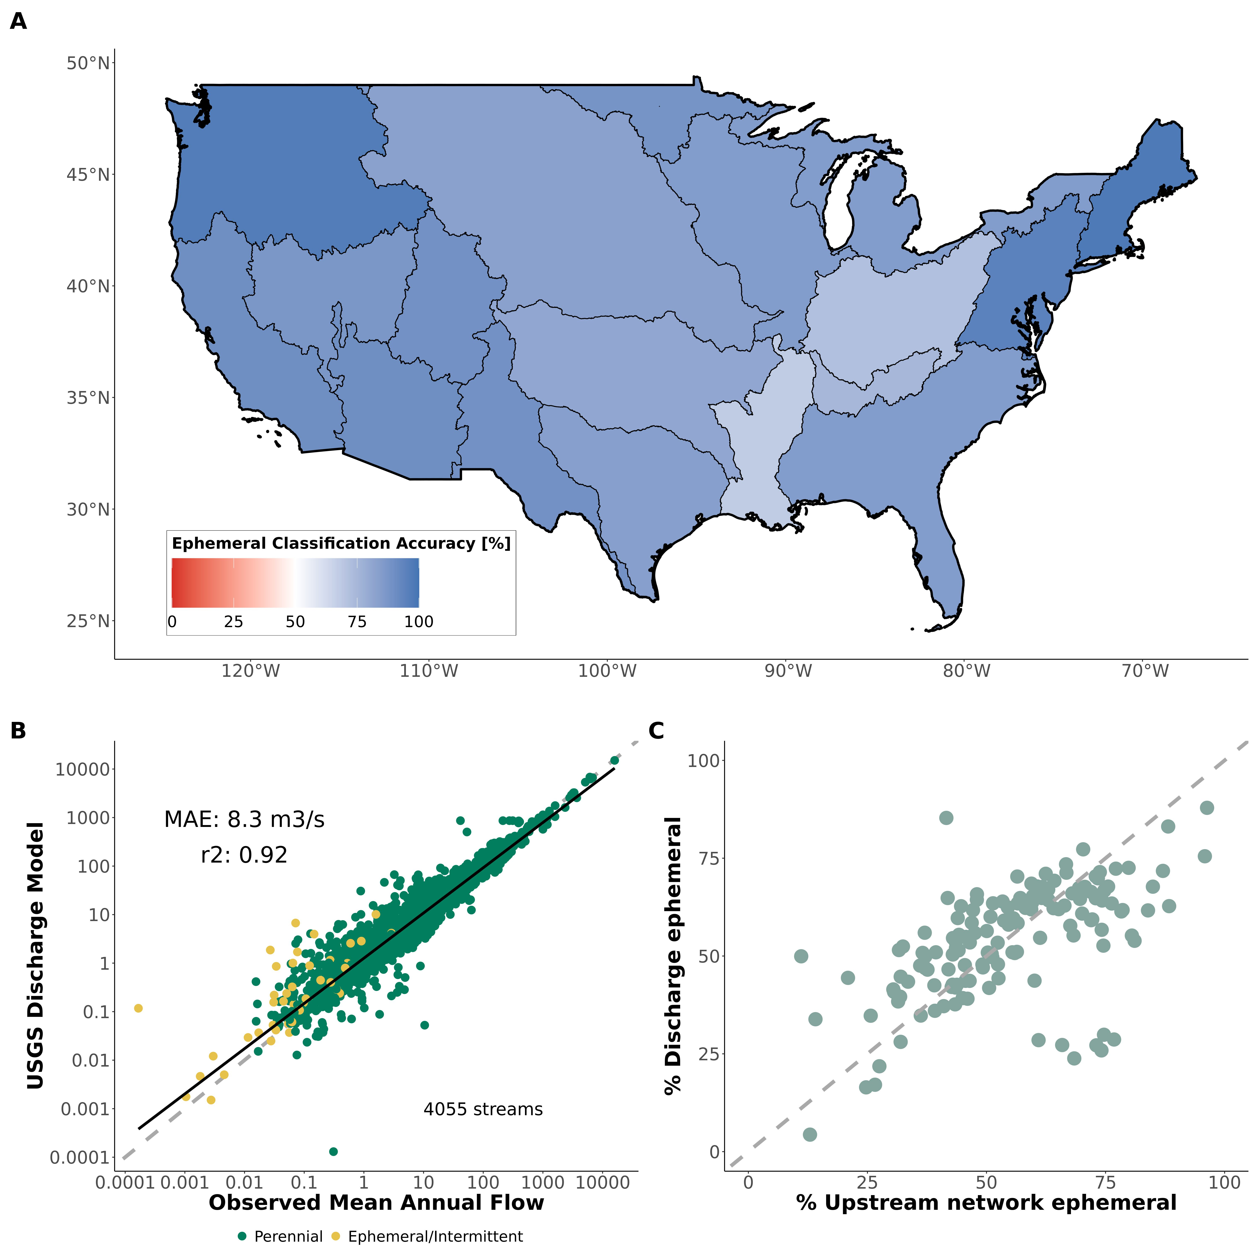

Fig. S1: Main validation/verification plots for model: (A) Regional classification accuracy of the ephemeral stream map against completely independent field assessments of stream ephemerality. (B) Validation of mean annual discharge model at approximately 4,000 streams across CONUS. (C) Verification that that the relative ephemeral contribution to discharge (by basin) cna be anticipated by upstream ephemeral network length (see Text S1 for more details).

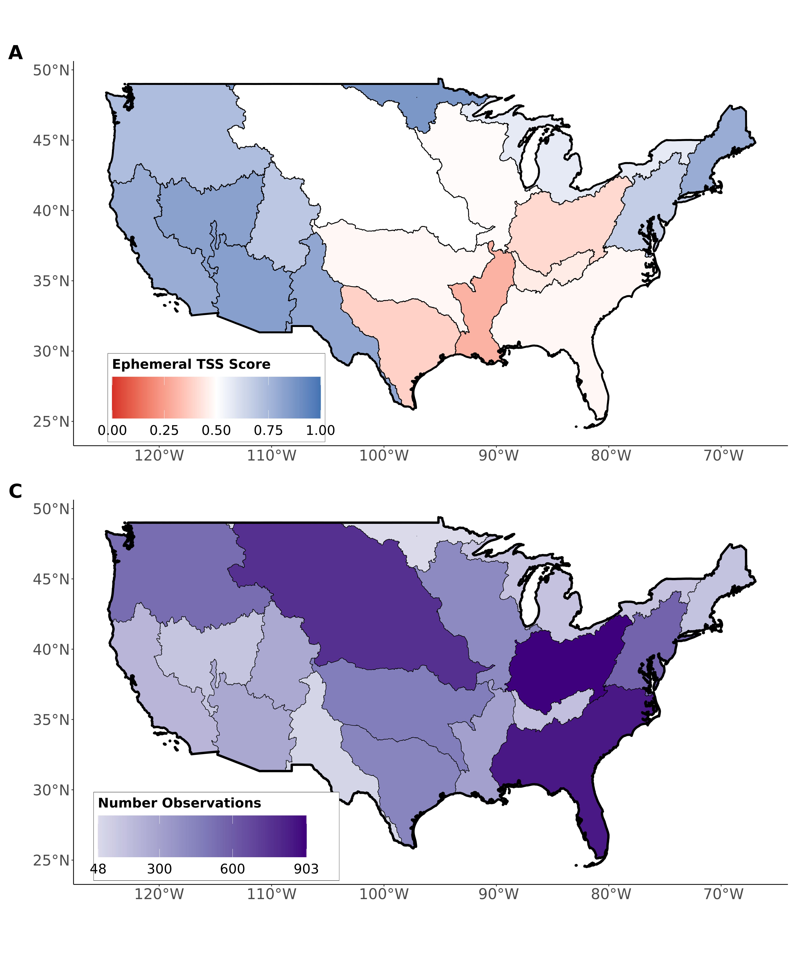

Fig. S2: Regional validations of the ephemeral stream classification model against completely independent field assessments of stream ephemerality: (A) regional model true skill score and (B) number of field-observations per region. The average number of regional observations is 376.

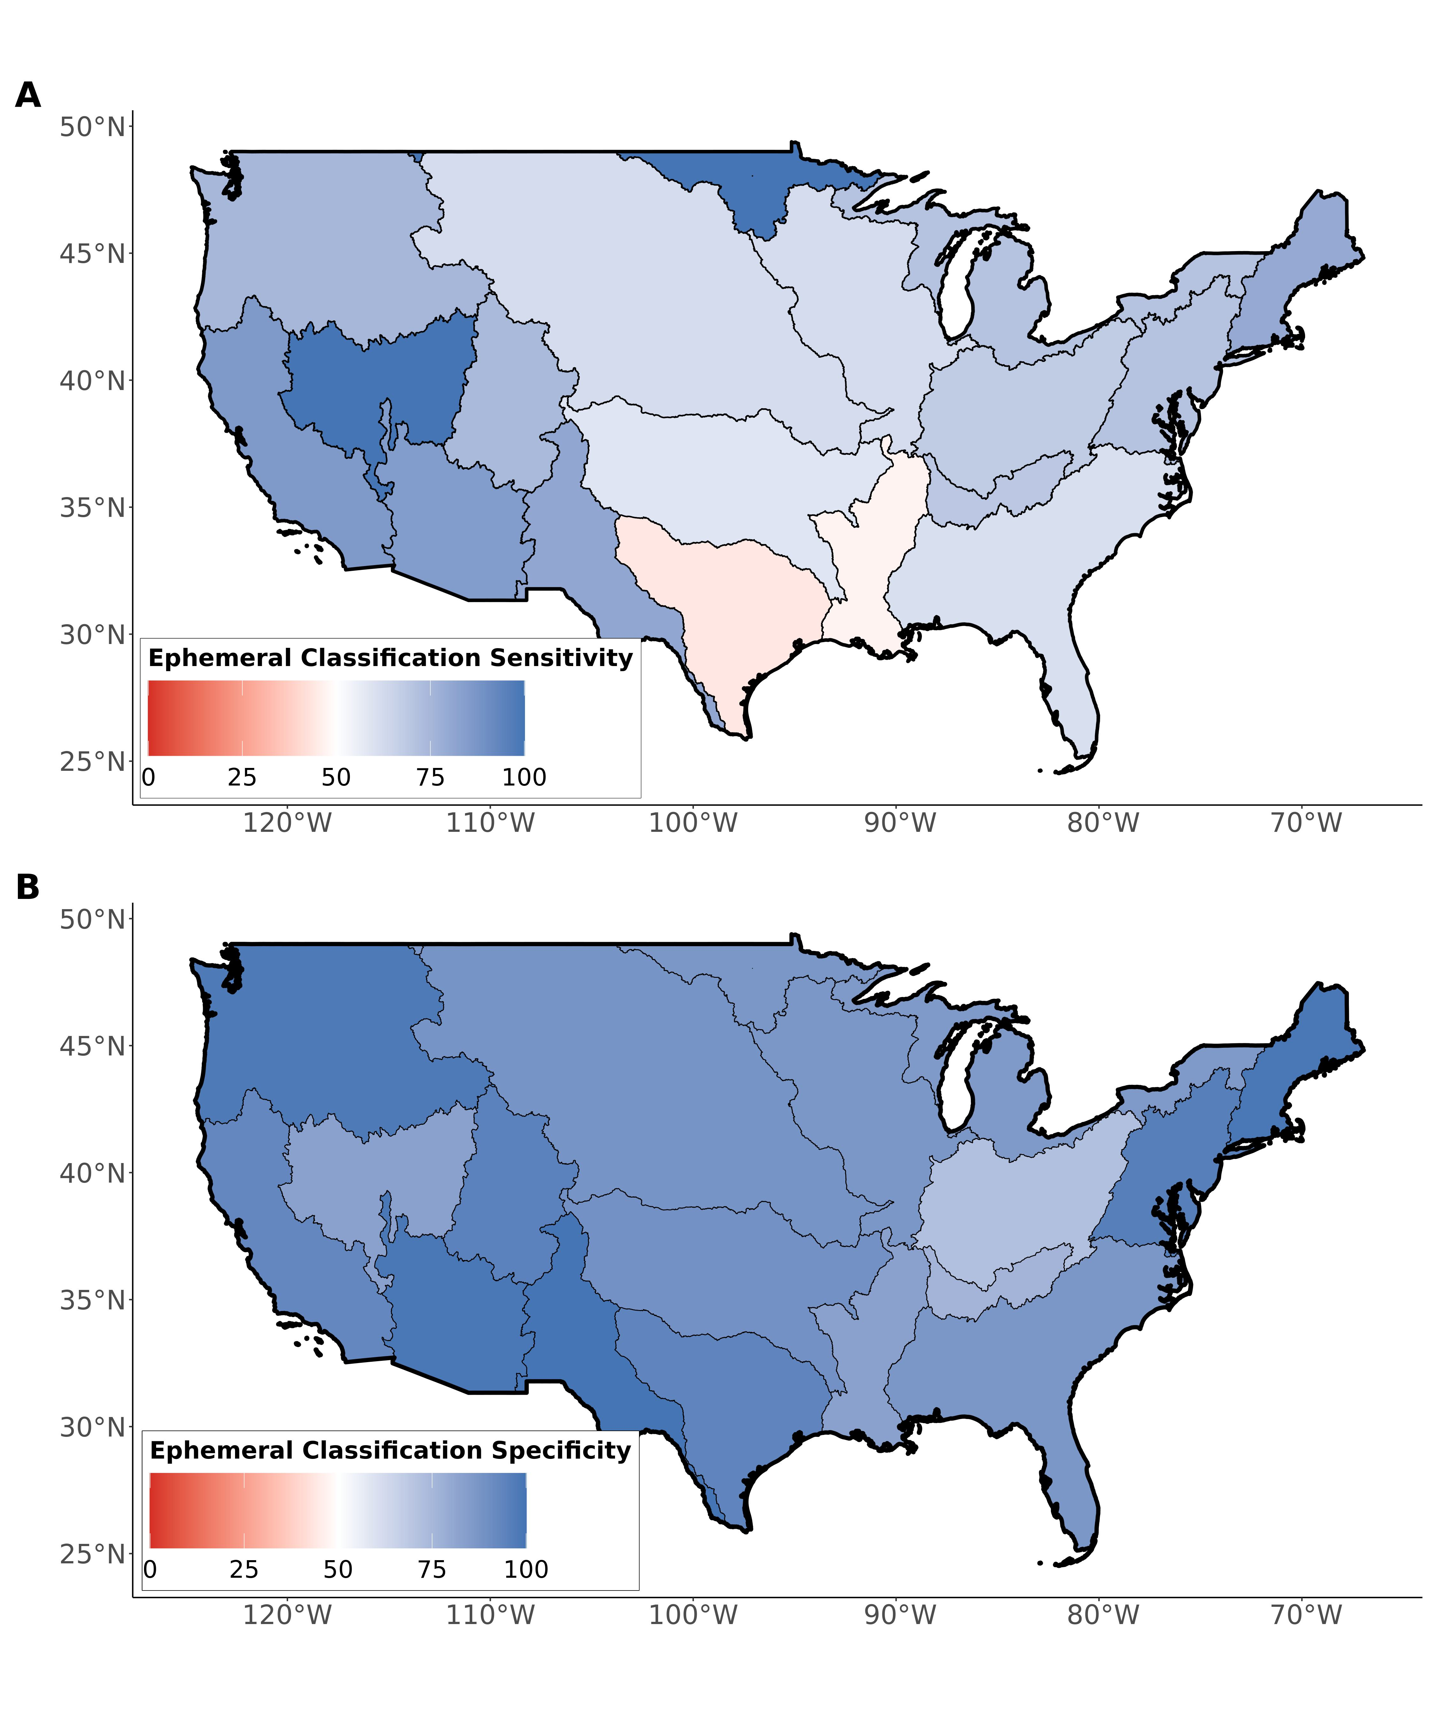

Fig. S3: Regional validations of the ephemeral stream classification model against completely independent field assessments of stream ephemerality: (A) regional model classification sensitivity and (B) specificity.

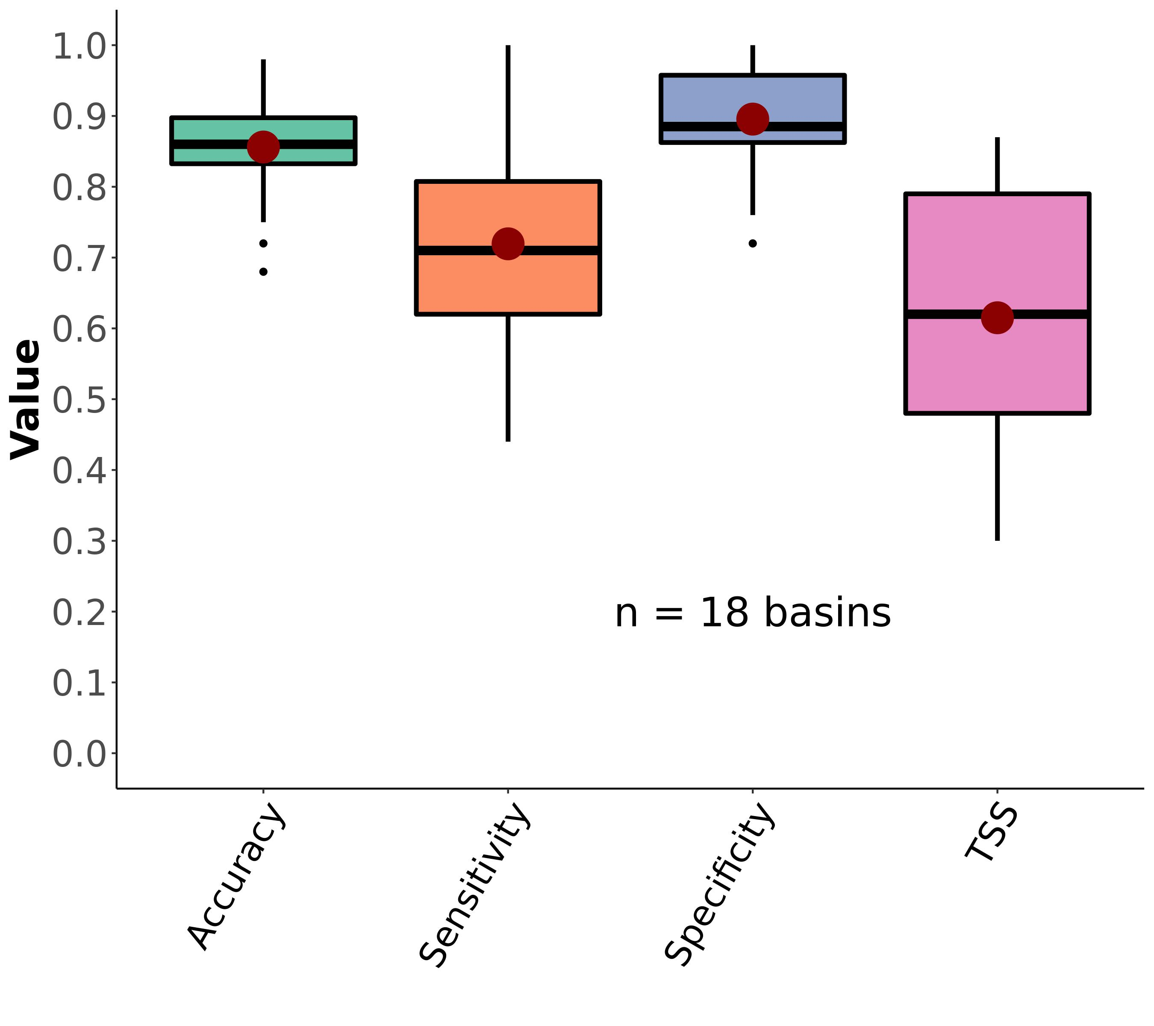

Fig. S4: Boxplots of regional ephemeral classification performance, by accuracy metric (section 3.2). Red dots correspond to the mean values. The outlier scores for sensitivity and TSS are from region HUC09 (Minnesota and Wisconsin draining to Canada). These poor scores are due to there only being 1 ephemeral stream in our dataset for that region. See Table S3 for metric definitions.

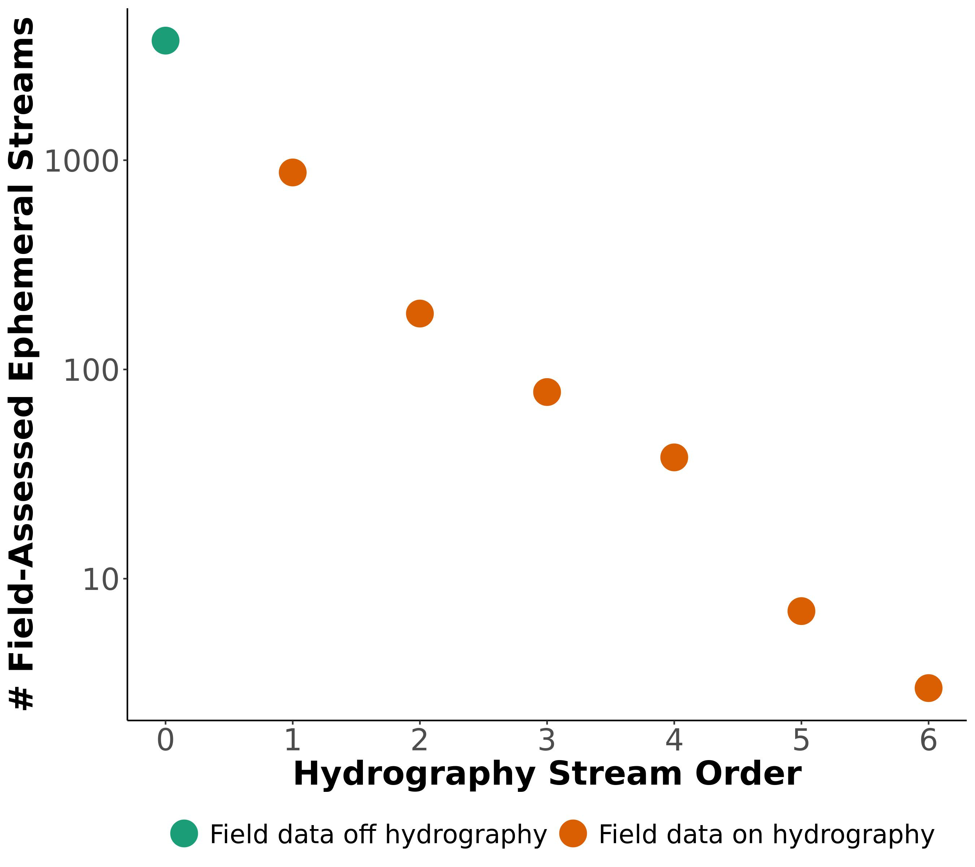

Fig. S5: Scaling model for CONUS ephemeral stream network. Orange points are associated with hydrography reaches while the green point is the number of ephemeral streams not associated with reaches and on streams too small to be included in the hydrography. 1 additional order is needed to ‘capture’ the green point and match this observed pattern in our data (See section 3.3 and Fig. S6).

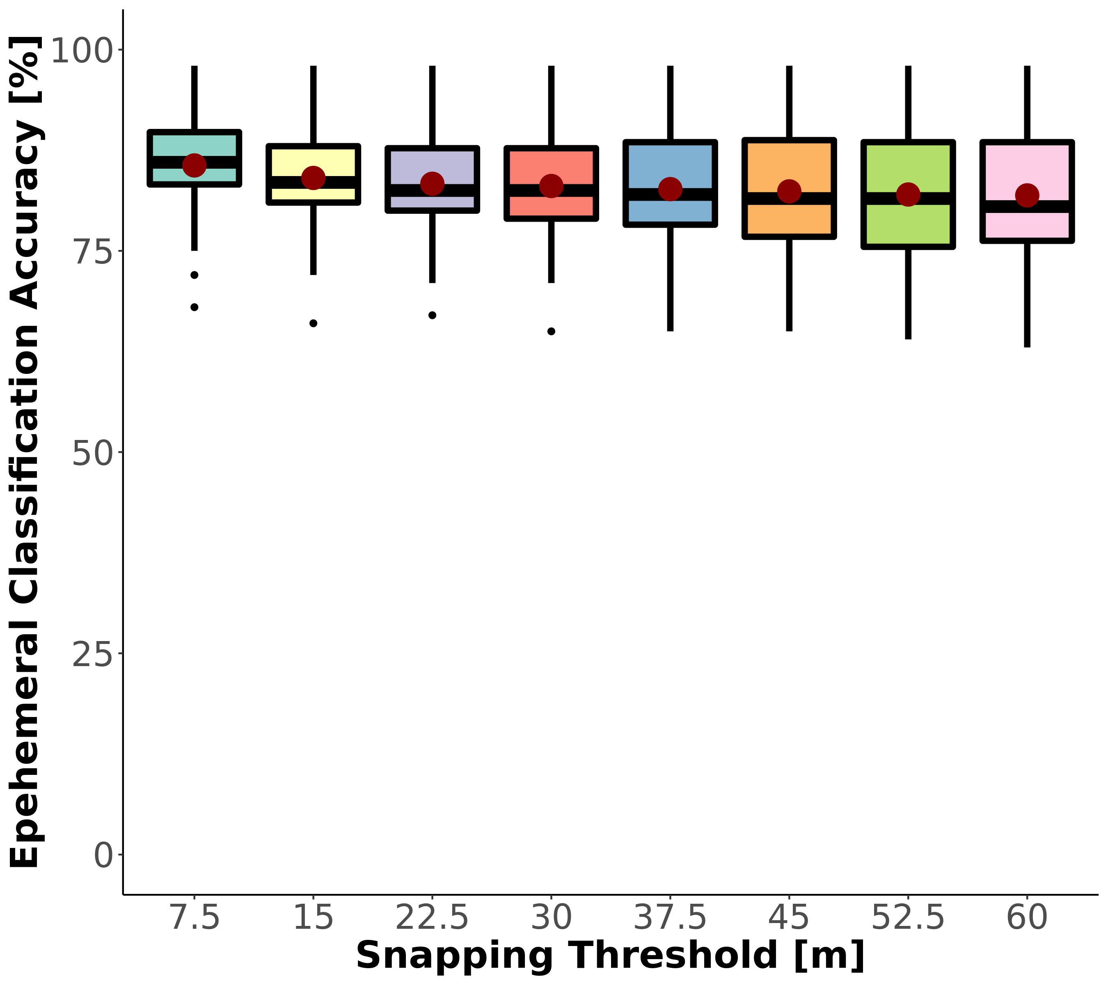

Fig. S6: Regional classification sensitivity to snapping threshold. Red points reflect the mean. Performance across the distributions (n=18 basins) is best (and normally distributed) at a snapping threshold of approximately 10-15m. A threshold of 1m yields artifically high classification performance because the threshold misses most small streams.

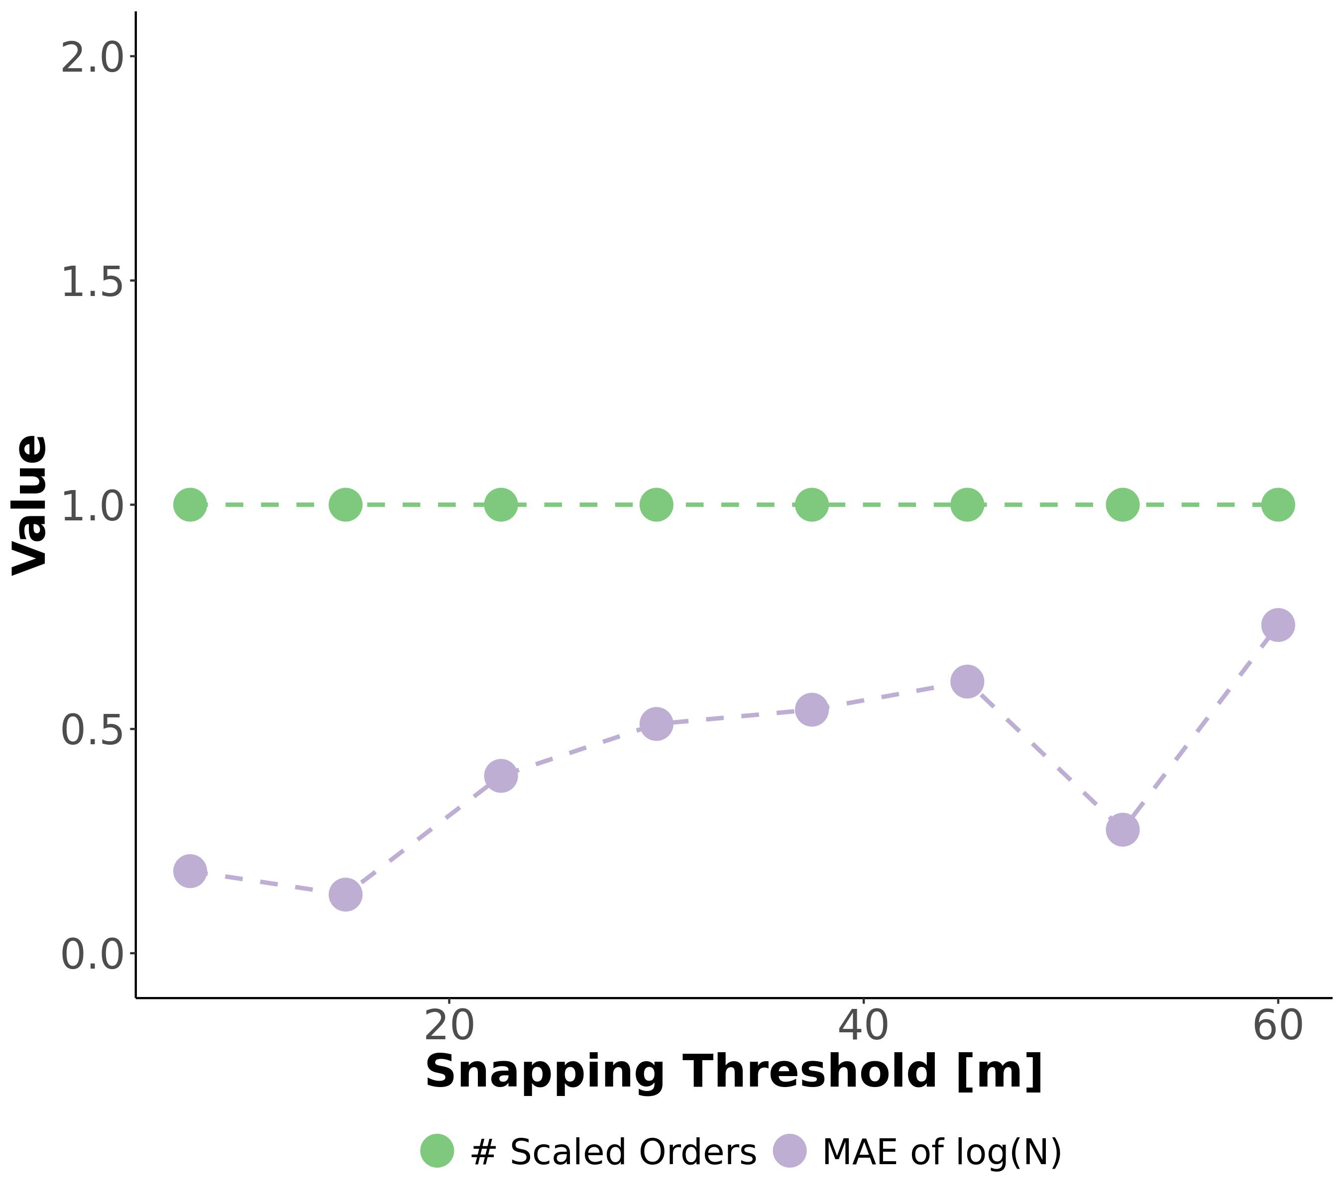

Fig. S7: Sensitivity test of the snapping threshold used to join field assessments of ephemerality to the drainage network. Green line is the number of additional stream orders (equation S5, given a snapping threshold). Purple line is the mean absolute error (MAE) of the Horton law of stream numbers (equation S4), given a snapping threshold. MAE should be smallest when the data best fit Horton’s laws, indicating that we are not missassinging field data to the wrong rivers (sections 1.4 and 3.3).

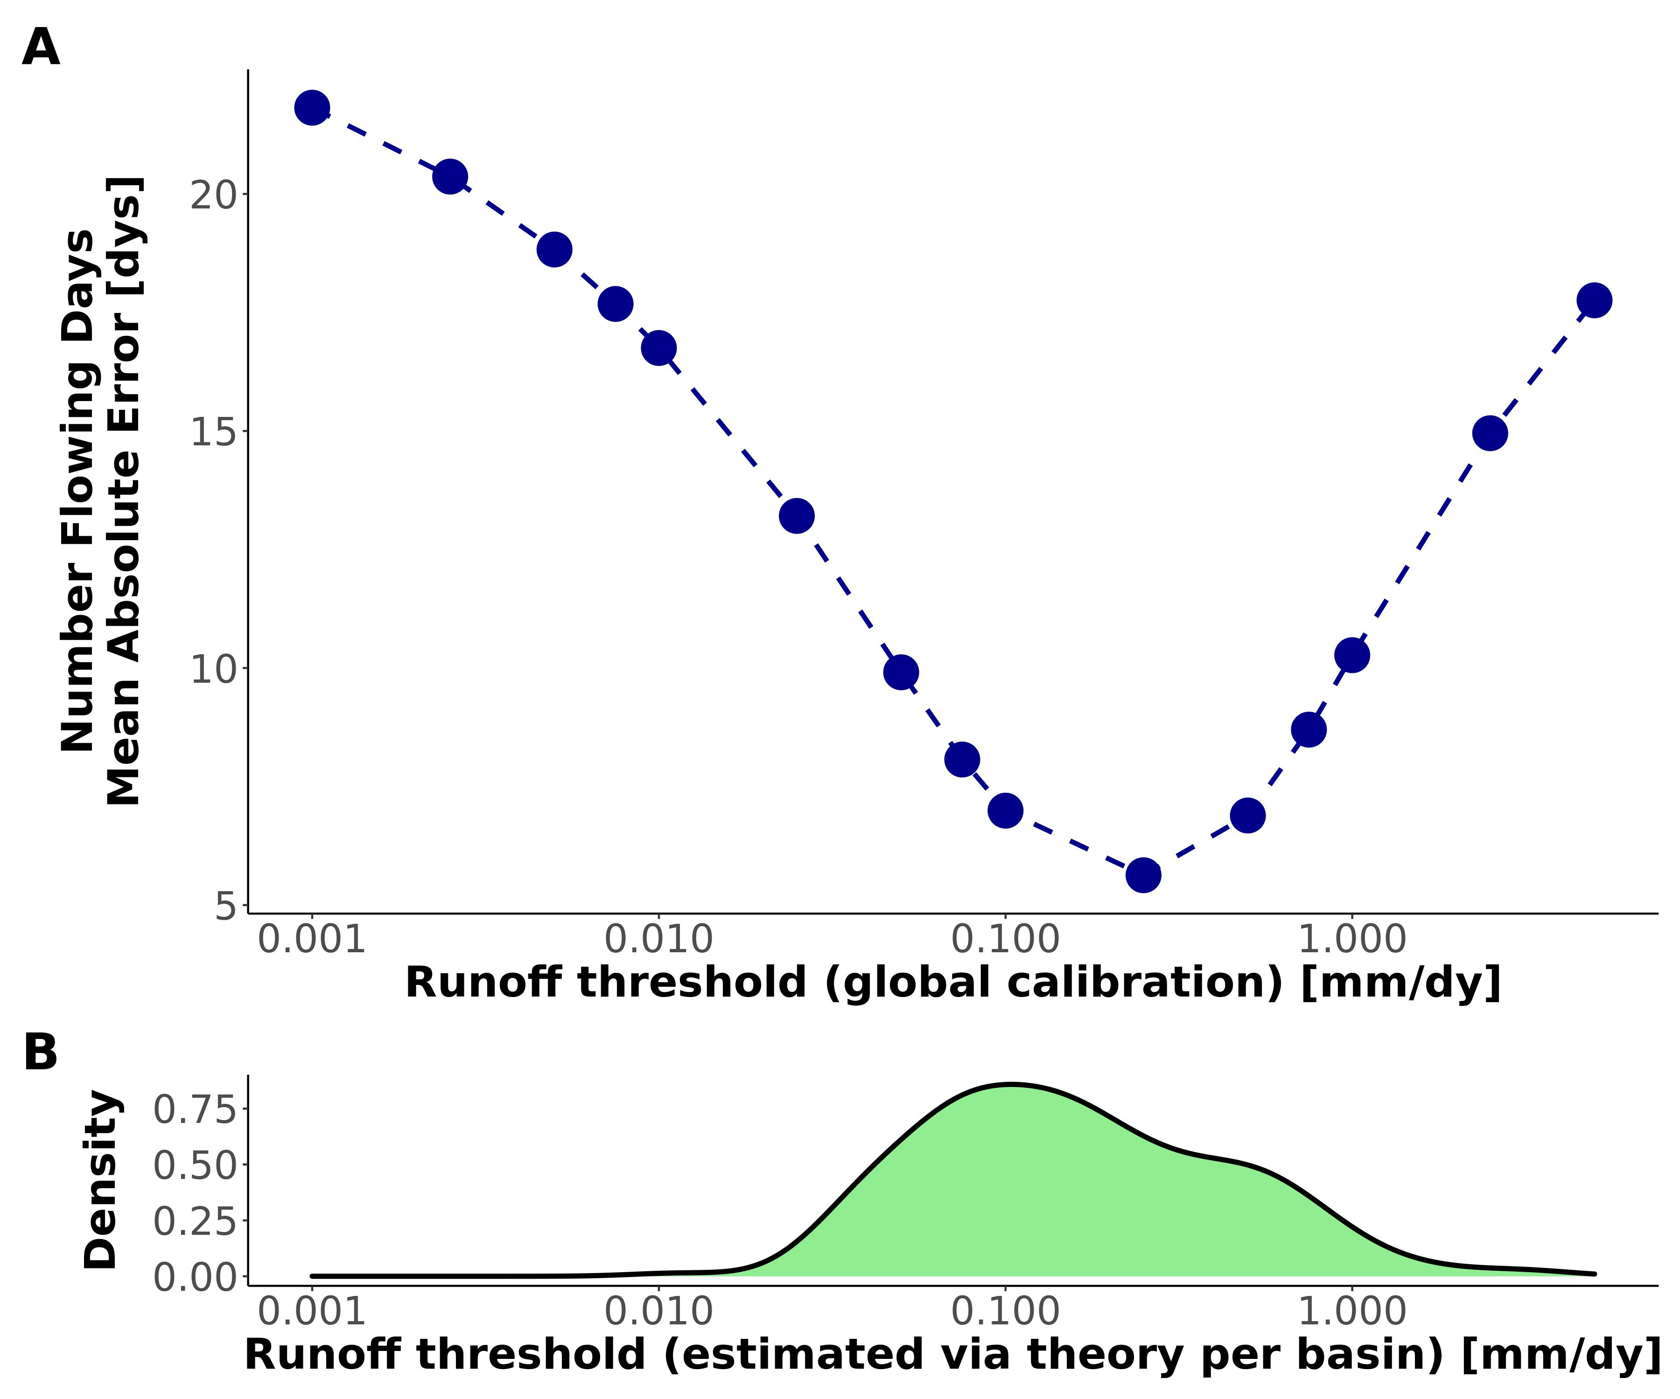

Fig. S8: Assessing our runoff threshold model ( $i_{min}$ via equation S7) by comparing it against a calibrated $i_{min}$ (section 4.2). (A) Global-scope calibration of $i_{min}$ to available $N_{flw}$ data (section 4.1). (B) CONUS distribution of basin $i_{min}$ calculated using equation S7. The latter model is the one used to generate the Fig. 3 results.

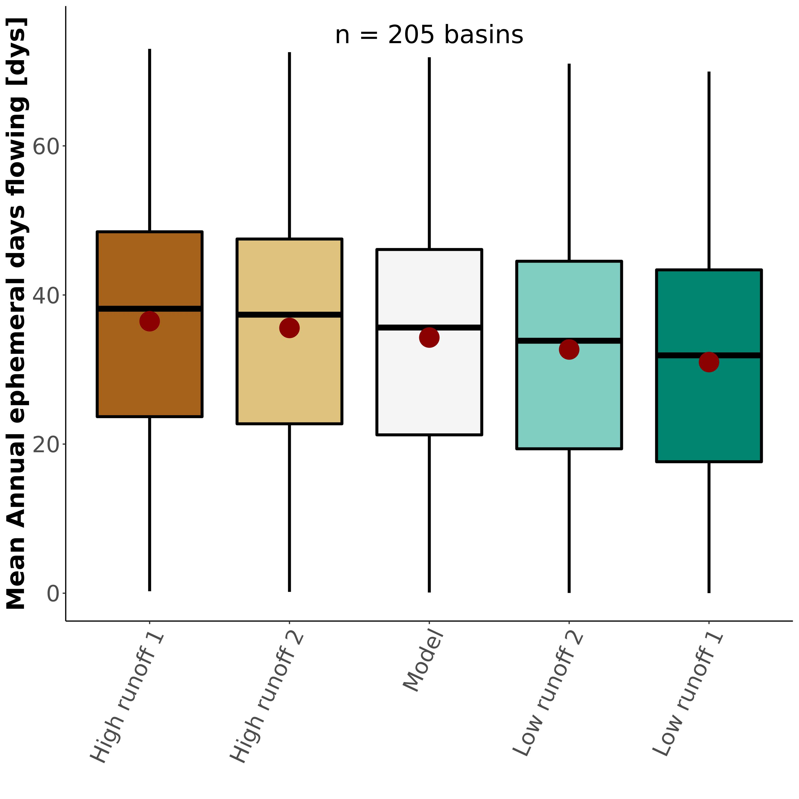

Fig. S9: Sensitivity test for $N_{flw}$ (section 4.2), resulting in boxplots of the basin-averaged, mean annual number of days that ephemeral streams flow (white boxplot is equivalent to Fig. 3a). Table S5 details the runoff scenarios used.



Fig. S10: Sample of 16/205 drainage network hydrography classified using our model. Sub-plot titles refer to the relative and absolute fractions of ephemeral water discharge from each drainage network. Note that foreign streams are mapped as ‘not ephemeral’ in these plots for visualization’s sake (e.g. lower Colorado in sub-panel (D).

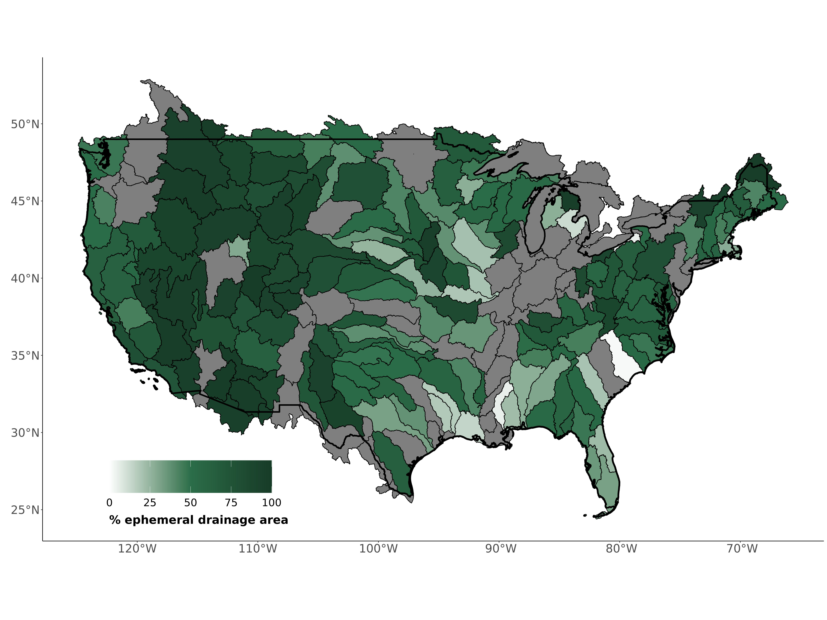

Fig. S11: Assessing ephemeral streams by landscape contribution Contiguous United States map of the basin fraction (% drainage area) that is ephemeral (equation S2).

## Supplementary Tables

**Table S1** Summary of models and geospatial data used to drive our model and generate our results. Point-based data used to validate is described in sections 1.4 and 4.1.

| Variable | Dataset Name | Spatial Resolution | Temporal Resolution | Years caputred | Reference |
| --- | --- | --- | --- | --- | --- |
| Hydrography | USGS National Hydrography dataset (NHD) | 1:24,000 | - | Long-term | (*19*) |
| Discharge | USGS discharge model | 1:24,000 | Year | 1970-2000 | (*19*) |
| Water Table Depth | Fan Global Soil Hydrology Model | 30” | Month | 2004-2014 | (*18*); (*33*) |
| Land Cover | National Land Cover Dataset (NLCD) | 30” (downscaled from 1”) | Year | 2019 | (*55*) |
| Precipitation | CPC Unified Gauge-based Daily Precipitation Model | 0.25’ | Day | 1980-2010 | (*21*); (*56*) |
| Runoff | USGS runoff data | USGS level 4 basins | Year | 1970-2021 | (*20*) |

**Table S2** Field assessments of stream ephemerality performed in New England (Summer 2022). We followed the ephemeral/intermittent/perennial protocol for the State of North Carolina Department of Water Quality (*30*). Scores $<$ 19 are deemed ‘ephemeral’.

| Name | Latitude | Longitude | Score | Classification |
| --- | --- | --- | --- | --- |
| Tucker1 | 42.95125 | -71.07311 | 5.5 | ephemeral |
| Tucker2 | 42.94875 | -71.07479 | 15.0 | ephemeral |
| Atkins1 | 42.41396 | -72.46797 | 16.5 | ephemeral |
| Atkins2 | 42.42449 | -72.48076 | 8.0 | ephemeral |
| Harkness1 | 42.36701 | -72.47190 | 12.5 | ephemeral |

**Table S3:** Classification metrics used to assess the ephemeral mapping model. *TP* is the true positive rate, *TN* is the true negative rate, *FP* is the false positive rate, and *FN* is the false negative rate.

| Name | Definition |
| --- | --- |
| Accuracy | $\frac{N_{TP}+N_{TN}}{N_{TP}+N_{TN}+N_{FP}+N_{FN}}$ |
| Sensitivity | $\frac{N_{TP}}{N_{TP}+N_{FN}}$ |
| Specificity | $\frac{N_{TN}}{N_{TN}+N_{FP}}$ |
| True Skill Score (TSS) | Sensitivity + Specificity - 1 |

**Table S4:** In situ measurements of mean annual number of flowing days for ephemeral streams, compared against the same value calculated via our model (Fig. 2b). Uncertainty refers to 1 $σ$ from the Monte Carlo simulations (section 5).

|  | Model Basin | Model Nflw [dys] | Model Uncertainty [dys] | Watershed | Observed Nflw [dys] | Reference |
| --- | --- | --- | --- | --- | --- | --- |
| 33 | Neuse-Pamlico | 41 | 14 | Duke Forest | 59 | Zimmer & McGlynn, 2017 |
| 60 | Lake Ontario and Niagara Peninsula | 42 | 21 | Guelph | 57 | Peirce & Lindsay, 2015 |
| 187 | Lower Gila | 4 | 5 | Goldwater | 1 | Stromberg et al. 2017 |
| 190 | Middle Gila | 6 | 8 | Huachuca | 2 | Stromberg et al. 2017 |
| 188 | Lower Colorado | 12 | 6 | Mohave | 2 | Kampf et al. 2018 |
| 177 | Rio Grande-Elephant Butte | 11 | 12 | Montoyas | 1 | Schoener 2022 |
| 201 | Middle Snake | 40 | 15 | Reynolds Creek | 28 | Slaughter et al. 2001 |
| 78 | Kentucky-Licking | 54 | 13 | Robinson Forest | 50 | Fritz et al. 2019 |
| 190.1 | Middle Gila | 6 | 8 | Santa Rita | 10 | Moran et al. 2008 |
| 190.2 | Middle Gila | 6 | 8 | Walnut Gulch | 7 | Moran et al. 2008 |
| 188.1 | Lower Colorado | 12 | 6 | Yuma | 2 | Kampf et al. 2018 |

**Table S5:** Runoff scenarios used in the $N_{flw}$ sensitivity analysis. See section 5.2 for more specifics.

| Name | Runoff Memory | Runoff ratio ($i_{r}$) |
| --- | --- | --- |
| Low runoff 1 | 10 days | $i_{r}+0.33i_{r}$ |
| Low runoff 2 | 6 days | $i_{r}+0.18i_{r}$ |
| High runoff 1 | 0 days | $i_{r}−0.33i_{r}$ |
| High runoff 2 | 1 day | $i_{r}+0.18i_{r}$ |

## References

1. Department of the Army, Corps of Engineers, E. P. Agency, The Navigable Waters Protection Rule: Definition of “Waters of the United States.” *Federal Register* (2020).

2. P. A. Raymond, J. E. Saiers, W. V. Sobczak, [Hydrological and biogeochemical controls on watershed dissolved organic matter transport: Pulse-shunt concept](https://doi.org/10.1890/14-1684.1). *Ecology*. **97**, 5–16 (2016).

3. B. He, S. Kanae, T. Oki, Y. Hirabayashi, Y. Yamashiki, K. Takara, [Assessment of global nitrogen pollution in rivers using an integrated biogeochemical modeling framework](https://doi.org/10.1016/j.watres.2011.02.011). *Water Research*. **45**, 2573–2586 (2011).

4. C. Schmidt, T. Krauth, S. Wagner, [Export of Plastic Debris by Rivers into the Sea](https://doi.org/10.1021/acs.est.7b02368). *Environmental Science & Technology*. **51**, 12246–12253 (2017).

5. M. Liu, Q. Zhang, T. Maavara, S. Liu, X. Wang, P. A. Raymond, [Rivers as the largest source of mercury to coastal oceans worldwide](https://doi.org/10.1038/s41561-021-00793-2). *Nature Geoscience*. **14**, 672–677 (2021).

6. L. C. Alexander, K. M. Fritz, K. A. Schofield, B. C. Autrey, J. E. DeMeester, H. E. Golden, D. C. Goodrich, W. G. Kepner, H. R. Kiperwas, C. R. Lane, S. D. LeDuc, S. G. Leibowitz, M. G. McManus, A. I. Pollard, C. E. Ridley, M. K. Vanderhoof, P. J. Wigington Jr., [Featured Collection Introduction: Connectivity of Streams and Wetlands to Downstream Waters](https://doi.org/10.1111/1752-1688.12630). *JAWRA Journal of the American Water Resources Association*. **54**, 287–297 (2018).

7. J. Harvey, J. Gomez-Velez, N. Schmadel, D. Scott, E. Boyer, R. Alexander, K. Eng, H. Golden, A. Kettner, C. Konrad, R. Moore, J. Pizzuto, G. Schwarz, C. Soulsby, J. Choi, [How Hydrologic Connectivity Regulates Water Quality in River Corridors](https://doi.org/10.1111/1752-1688.12691). *JAWRA Journal of the American Water Resources Association*. **55**, 369–381 (2019).

8. D. A. Keiser, J. S. Shapiro, [Consequences of the Clean Water Act and the Demand for Water Quality*](https://doi.org/10.1093/qje/qjy019). *The Quarterly Journal of Economics*. **134**, 349–396 (2019).

9. M. L. Messager, B. Lehner, C. Cockburn, N. Lamouroux, H. Pella, T. Snelder, K. Tockner, T. Trautmann, C. Watt, T. Datry, [Global prevalence of non-perennial rivers and streams](https://doi.org/10.1038/s41586-021-03565-5). *Nature*. **594**, 391–397 (2021).

10. K. L. Jaeger, R. Sando, R. R. McShane, J. B. Dunham, D. P. Hockman-Wert, K. E. Kaiser, K. Hafen, J. C. Risley, K. W. Blasch, [Probability of Streamflow Permanence Model (PROSPER): A spatially continuous model of annual streamflow permanence throughout the Pacific Northwest](https://doi.org/10.1016/j.hydroa.2018.100005). *Journal of Hydrology X*. **2**, 100005 (2019).

11. N. Durighetto, V. Mariotto, F. Zanetti, K. J. McGuire, G. Mendicino, A. Senatore, G. Botter, [Probabilistic Description of Streamflow and Active Length Regimes in Rivers](https://doi.org/10.1029/2021WR031344). *Water Resources Research*. **58**, e2021WR031344 (2022).

12. P. P. Russell, S. M. Gale, B. Muñoz, J. R. Dorney, M. J. Rubino, [A Spatially Explicit Model for Mapping Headwater Streams](https://doi.org/10.1111/jawr.12250). *JAWRA Journal of the American Water Resources Association*. **51**, 226–239 (2015).

13. K. A. Fesenmyer, S. J. Wenger, D. S. Leigh, H. M. Neville, [Large portion of USA streams lose protection with new interpretation of Clean Water Act](https://doi.org/10.1086/713084). *Freshwater Science*. **40**, 252–258 (2021).

14. R. B. Alexander, E. W. Boyer, R. A. Smith, G. E. Schwarz, R. B. Moore, [The Role of Headwater Streams in Downstream Water Quality1](https://doi.org/10.1111/j.1752-1688.2007.00005.x). *JAWRA Journal of the American Water Resources Association*. **43**, 41–59 (2007).

15. K. M. Fritz, K. A. Schofield, L. C. Alexander, M. G. McManus, H. E. Golden, C. R. Lane, W. G. Kepner, S. D. LeDuc, J. E. DeMeester, A. I. Pollard, [Physical and Chemical Connectivity of Streams and Riparian Wetlands to Downstream Waters: A Synthesis](https://doi.org/10.1111/1752-1688.12632). *JAWRA Journal of the American Water Resources Association*. **54**, 323–345 (2018).

16. S. M. P. Sullivan, M. C. Rains, A. D. Rodewald, W. W. Buzbee, A. D. Rosemond, [Distorting science, putting water at risk](https://doi.org/10.1126/science.abb6899). *Science*. **369**, 766–768 (2020).

17. Materials and methods are available as supplementary materials at the Science website.

18. Y. Fan, G. Miguez-Macho, E. G. Jobbágy, R. B. Jackson, C. Otero-Casal, [Hydrologic regulation of plant rooting depth](https://doi.org/10.1073/pnas.1712381114). *Proceedings of the National Academy of Sciences*. **114**, 10572–10577 (2017).

19. U. S. G. Survey, National Hydrography Dataset (ver. USGS National Hydrography Dataset High Resolution(NHD-HR) for Hydrologic Unit (HU) 4 (2022).

20. J. w. Brakebill, D. m. Wolock, S. e. Terziotti, [Digital Hydrologic Networks Supporting Applications Related to Spatially Referenced Regression Modeling1](https://doi.org/10.1111/j.1752-1688.2011.00578.x). *JAWRA Journal of the American Water Resources Association*. **47**, 916–932 (2011).

21. P. Xie, M. Chen, S. Yang, A. Yatagai, T. Hayasaka, Y. Fukushima, C. Liu, [A Gauge-Based Analysis of Daily Precipitation over East Asia](https://doi.org/10.1175/JHM583.1). *Journal of Hydrometeorology*. **8**, 607–626 (2007).

22. C. B. Brinkerhoff, P. A. Raymond, T. Maavara, Y. Ishitsuka, K. S. Aho, C. J. Gleason, [Lake Morphometry and River Network Controls on Evasion of Terrestrially Sourced Headwater CO2](https://doi.org/10.1029/2020GL090068). *Geophysical Research Letters*. **48**, e2020GL090068 (2021).

23. T. Gleeson, L. Marklund, L. Smith, A. H. Manning, Classifying the water table at regional to continental scales. *Geophysical Research Letters*. **38** (2011), doi:[10.1029/2010GL046427](https://doi.org/10.1029/2010GL046427).

24. L. E. Condon, R. M. Maxwell, [Evaluating the relationship between topography and groundwater using outputs from a continental-scale integrated hydrology model](https://doi.org/10.1002/2014WR016774). *Water Resources Research*. **51**, 6602–6621 (2015).

25. D. c. Goodrich, W. g. Kepner, L. r. Levick, P. j. Wigington Jr., [Southwestern Intermittent and Ephemeral Stream Connectivity](https://doi.org/10.1111/1752-1688.12636). *JAWRA Journal of the American Water Resources Association*. **54**, 400–422 (2018).

26. B. R. Scanlon, C. C. Faunt, L. Longuevergne, R. C. Reedy, W. M. Alley, V. L. McGuire, P. B. McMahon, [Groundwater depletion and sustainability of irrigation in the US High Plains and Central Valley](https://doi.org/10.1073/pnas.1200311109). *Proceedings of the National Academy of Sciences*. **109**, 9320–9325 (2012).

27. C. B. Brinkerhoff, C. J. Gleason, C. J. Zappa, P. A. Raymond, M. E. Harlan, [Remotely Sensing River Greenhouse Gas Exchange Velocity Using the SWOT Satellite](https://doi.org/10.1029/2022GB007419). *Global Biogeochemical Cycles*. **36**, e2022GB007419 (2022).

28. B. B. Cael, A. J. Heathcote, D. A. Seekell, [The volume and mean depth of Earth’s lakes](https://doi.org/10.1002/2016GL071378). *Geophysical Research Letters*. **44**, 209–218 (2017).

29. USEPA, CWA Approved JDs.

30. J. Dorney, P. Russell, "[Chapter 4.1.1 - North Carolina Division of Water Quality Methodology for Identification of Intermittent and Perennial Streams and Their Origins](https://doi.org/10.1016/B978-0-12-805091-0.00014-1)" in *Wetland and Stream Rapid Assessments*, J. Dorney, R. Savage, R. W. Tiner, P. Adamus, Eds. (Academic Press, 2018), pp. 273–279.

31. C. A. Krabbenhoft, G. H. Allen, P. Lin, S. E. Godsey, D. C. Allen, R. M. Burrows, A. G. DelVecchia, K. M. Fritz, M. Shanafield, A. J. Burgin, M. A. Zimmer, T. Datry, W. K. Dodds, C. N. Jones, M. C. Mims, C. Franklin, J. C. Hammond, S. Zipper, A. S. Ward, K. H. Costigan, H. E. Beck, J. D. Olden, [Assessing placement bias of the global river gauge network](https://doi.org/10.1038/s41893-022-00873-0). *Nature Sustainability*. **5**, 586–592 (2022).

32. M. A. Zimmer, K. E. Kaiser, J. R. Blaszczak, S. C. Zipper, J. C. Hammond, K. M. Fritz, K. H. Costigan, J. Hosen, S. E. Godsey, G. H. Allen, S. Kampf, R. M. Burrows, C. A. Krabbenhoft, W. Dodds, R. Hale, J. D. Olden, M. Shanafield, A. G. DelVecchia, A. S. Ward, M. C. Mims, T. Datry, M. T. Bogan, K. S. Boersma, M. H. Busch, C. N. Jones, A. J. Burgin, D. C. Allen, [Zero or not? Causes and consequences of zero-flow stream gage readings](https://doi.org/10.1002/wat2.1436). *WIREs Water*. **7**, e1436 (2020).

33. Y. Fan, H. Li, G. Miguez-Macho, [Global Patterns of Groundwater Table Depth](https://doi.org/10.1126/science.1229881). *Science*. **339**, 940–943 (2013).

34. L. E. Condon, S. Kollet, M. F. P. Bierkens, G. E. Fogg, R. M. Maxwell, M. C. Hill, H.-J. H. Fransen, A. Verhoef, A. F. Van Loon, M. Sulis, C. Abesser, [Global Groundwater Modeling and Monitoring: Opportunities and Challenges](https://doi.org/10.1029/2020WR029500). *Water Resources Research*. **57**, e2020WR029500 (2021).

35. I. E. M. de Graaf, E. H. Sutanudjaja, L. P. H. van Beek, M. F. P. Bierkens, [A high-resolution global-scale groundwater model](https://doi.org/10.5194/hess-19-823-2015). *Hydrology and Earth System Sciences*. **19**, 823–837 (2015).

36. O. Allouche, A. Tsoar, R. Kadmon, [Assessing the accuracy of species distribution models: Prevalence, kappa and the true skill statistic (TSS)](https://doi.org/10.1111/j.1365-2664.2006.01214.x). *Journal of Applied Ecology*. **43**, 1223–1232 (2006).

37. R. E. Horton, [EROSIONAL DEVELOPMENT OF STREAMS AND THEIR DRAINAGE BASINS; HYDROPHYSICAL APPROACH TO QUANTITATIVE MORPHOLOGY](https://doi.org/10.1130/0016-7606(1945)56[275:EDOSAT]2.0.CO;2). *GSA Bulletin*. **56**, 275–370 (1945).

38. J. W. Kirchner, [Statistical inevitability of Horton’s laws and the apparent randomness of stream channel networks](https://doi.org/10.1130/0091-7613(1993)021<0591:SIOHSL>2.3.CO;2). *Geology*. **21**, 591–594 (1993).

39. L. E. Milton, [The Geomorphic Irrelevance of Some Drainage Net Laws](https://doi.org/10.1111/j.1467-8470.1966.tb00055.x). *Australian Geographical Studies*. **4**, 89–95 (1966).

40. K. L. BOWDEN, J. R. WALLIS, [EFFECT OF STREAM-ORDERING TECHNIQUE ON HORTON’S LAWS OF DRAINAGE COMPOSITION](https://doi.org/10.1130/0016-7606(1964)75[767:EOSTOH]2.0.CO;2). *GSA Bulletin*. **75**, 767–774 (1964).

41. M. A. Zimmer, B. L. McGlynn, [Bidirectional streamgroundwater flow in response to ephemeral and intermittent streamflow and groundwater seasonality](https://doi.org/10.1002/hyp.11301). *Hydrological Processes*. **31**, 3871–3880 (2017).

42. K. M. Fritz, G. J. Pond, B. R. Johnson, C. D. Barton, [Coarse particulate organic matter dynamics in ephemeral tributaries of a Central Appalachian stream network](https://doi.org/10.1002/ecs2.2654). *Ecosphere*. **10**, e02654 (2019).

43. S. K. Kampf, J. Faulconer, J. R. Shaw, M. Lefsky, J. W. Wagenbrenner, D. J. Cooper, [Rainfall Thresholds for Flow Generation in Desert Ephemeral Streams](https://doi.org/10.1029/2018WR023714). *Water Resources Research*. **54**, 9935–9950 (2018).

44. C. W. Slaughter, D. Marks, G. N. Flerchinger, S. S. Van Vactor, M. Burgess, [Thirty-five years of research data collection at the Reynolds Creek Experimental Watershed, Idaho, United States](https://doi.org/10.1029/2001WR000413). *Water Resources Research*. **37**, 2819–2823 (2001).

45. M. S. Moran, C. D. Holifield Collins, D. C. Goodrich, J. Qi, D. T. Shannon, A. Olsson, Long-term remote sensing database, Walnut Gulch Experimental Watershed, Arizona, United States. *Water Resources Research*. **44** (2008), doi:[10.1029/2006WR005689](https://doi.org/10.1029/2006WR005689).

46. G. Schoener, [Impact of urbanization and stormwater infrastructure on ephemeral channel transmission loss in a semiarid watershed](https://doi.org/10.1016/j.ejrh.2022.101089). *Journal of Hydrology: Regional Studies*. **41**, 101089 (2022).

47. J. C. Stromberg, D. L. Setaro, E. L. Gallo, K. A. Lohse, T. Meixner, [Riparian vegetation of ephemeral streams](https://doi.org/10.1016/j.jaridenv.2016.12.004). *Journal of Arid Environments*. **138**, 27–37 (2017).

48. S. E. Peirce, J. B. Lindsay, [Characterizing ephemeral streams in a southern Ontario watershed using electrical resistance sensors](https://doi.org/10.1002/hyp.10136). *Hydrological Processes*. **29**, 103–111 (2015).

49. K. M. Fritz, S. Fulton, B. R. Johnson, C. D. Barton, J. D. Jack, D. A. Word, R. A. Burke, [Structural and functional characteristics of natural and constructed channels draining a reclaimed mountaintop removal and valley fill coal mine](https://doi.org/10.1899/09-060.1). *Journal of the North American Benthological Society*. **29**, 673–689 (2010).

50. T. C. Winter, *Ground Water and Surface Water: A Single Resource* (DIANE Publishing, 1999).

51. M. A. Zimmer, B. L. McGlynn, [Lateral, Vertical, and Longitudinal Source Area Connectivity Drive Runoff and Carbon Export Across Watershed Scales](https://doi.org/10.1002/2017WR021718). *Water Resources Research*. **54**, 1576–1598 (2018).

52. G. H. Allen, T. M. Pavelsky, E. A. Barefoot, M. P. Lamb, D. Butman, A. Tashie, C. J. Gleason, [Similarity of stream width distributions across headwater systems](https://doi.org/10.1038/s41467-018-02991-w). *Nature Communications*. **9**, 610 (2018).

53. E. Moges, B. L. Ruddell, L. Zhang, J. M. Driscoll, L. G. Larsen, [Strength and Memory of Precipitation’s Control Over Streamflow Across the Conterminous United States](https://doi.org/10.1029/2021WR030186). *Water Resources Research*. **58**, e2021WR030186 (2022).

54. S. Zanardo, I. Zaliapin, E. Foufoula-Georgiou, [Are American rivers Tokunaga self-similar? New results on fluvial network topology and its climatic dependence](https://doi.org/10.1029/2012JF002392). *Journal of Geophysical Research: Earth Surface*. **118**, 166–183 (2013).

55. J. Dewitz, National Land Cover Database (NLCD) 2019 Products (2021), doi:[10.5066/P9KZCM54](https://doi.org/10.5066/P9KZCM54).

56. M. Chen, W. Shi, P. Xie, V. B. S. Silva, V. E. Kousky, R. Wayne Higgins, J. E. Janowiak, Assessing objective techniques for gauge-based analyses of global daily precipitation. *Journal of Geophysical Research: Atmospheres*. **113** (2008), doi:[10.1029/2007JD009132](https://doi.org/10.1029/2007JD009132).